Autoscaling Task

Task01: Create one VPC in N. Virginia region:
Let’s create a VPC in N. Virginia region
Go to VPC Service
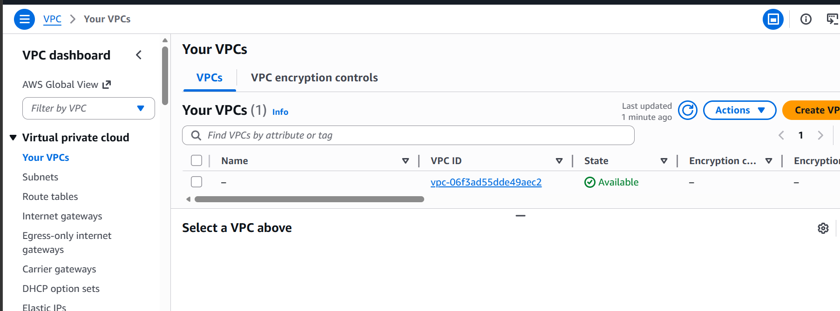

Click on create VPC
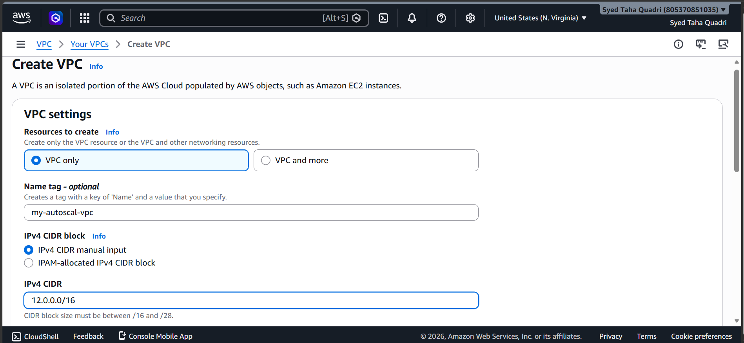
Give it a name and CIDR.
Click on create VPC
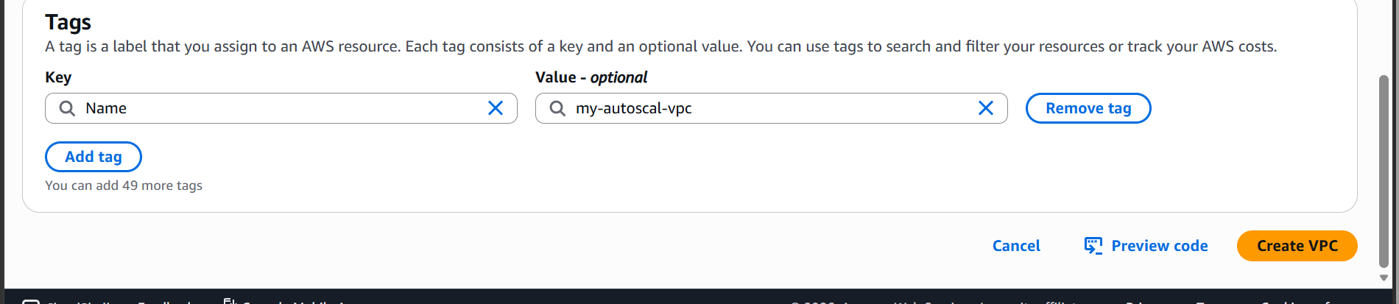

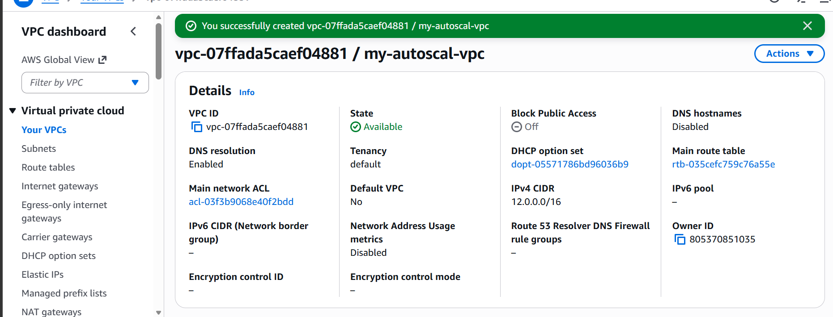

VPC is now created.

Task02: Create two subnets one public and one private subnet
Lets now create subnet
Click on subnets under VPC options
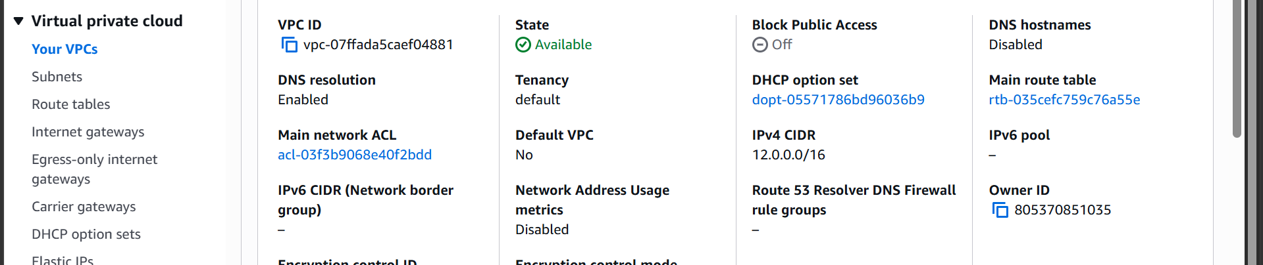
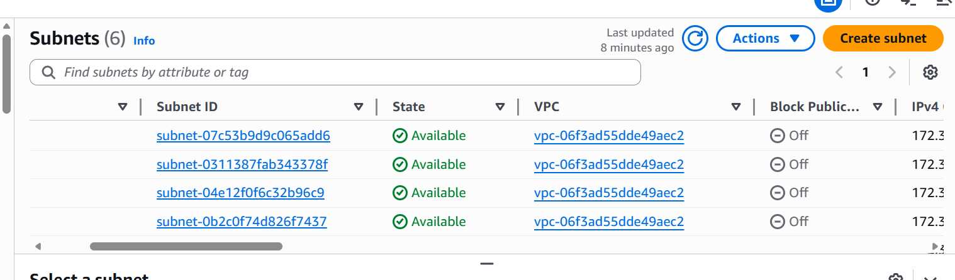

now click on create subnet
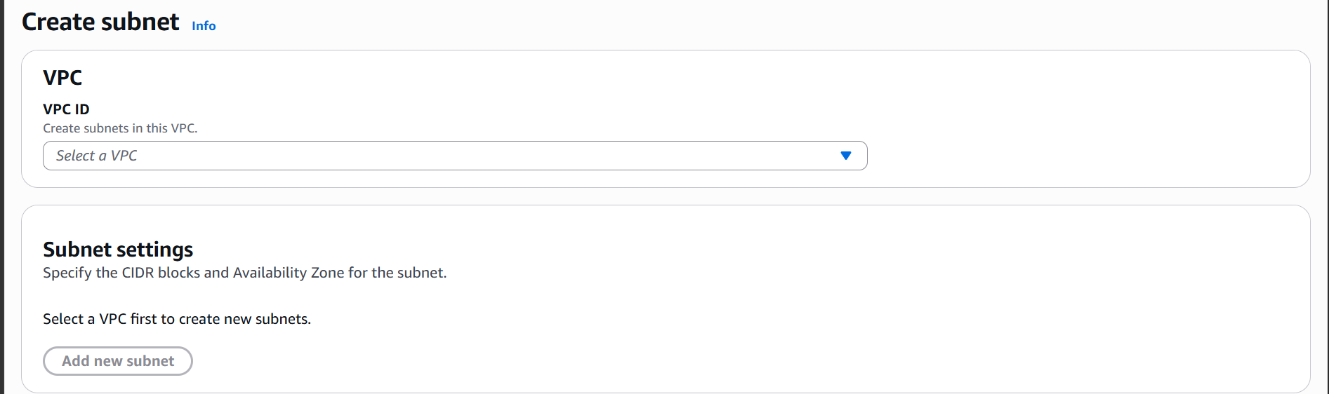

Selecting our newly created VPC
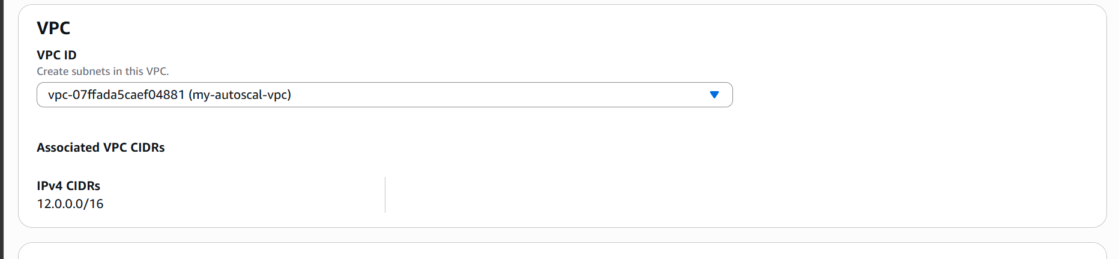
Now create two subnets
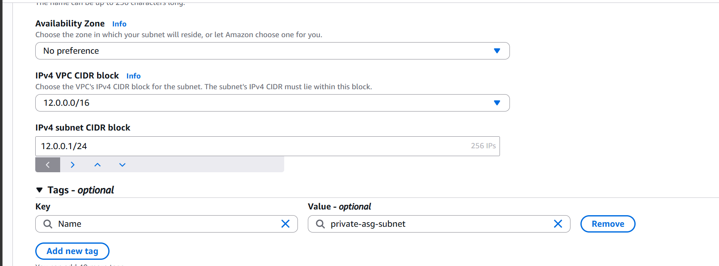

We have now created two subnets
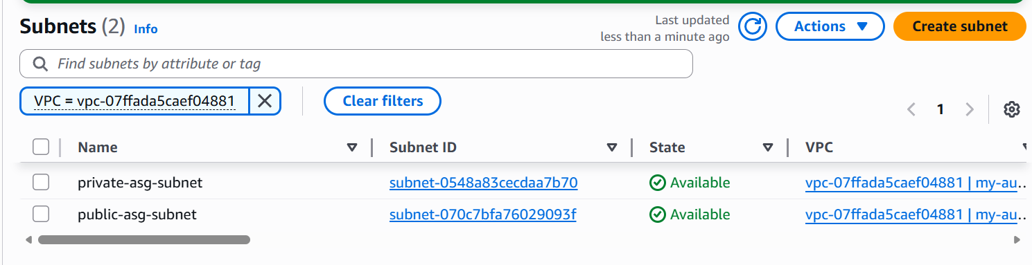

Task03 : Attach an IGW to vpc
Lets now attach an IGW our new VPC
Go to internet gateway under VPC
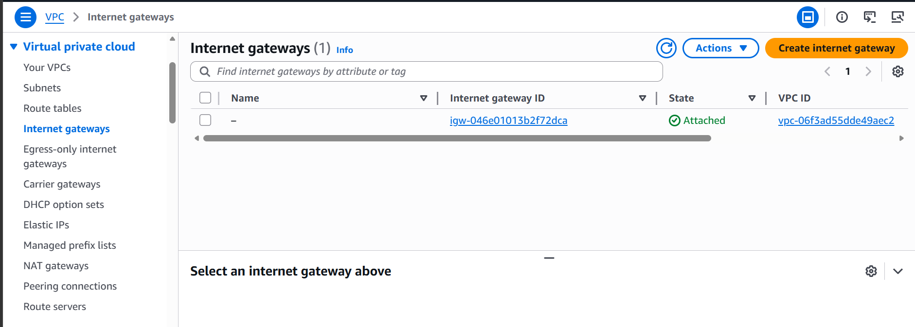

Now click on create Internet Gateway
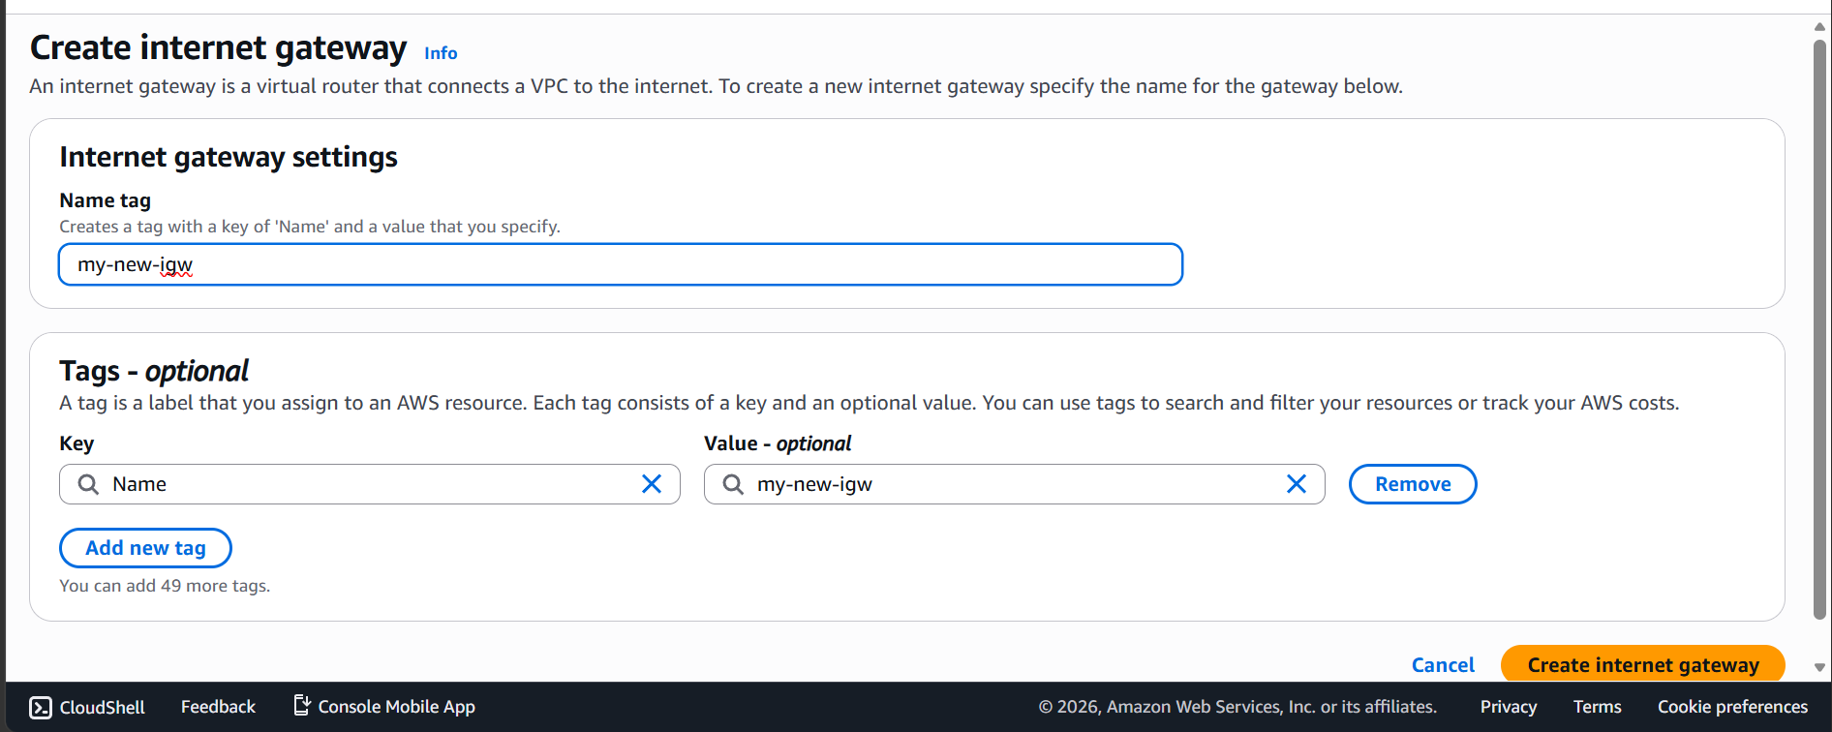
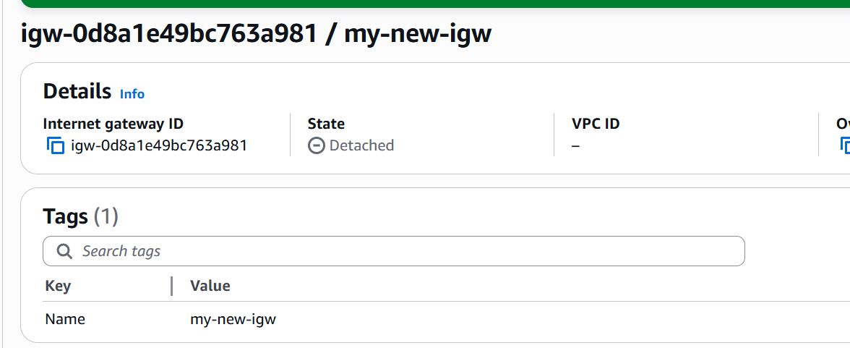

Our IGW is now created lets now attach it.
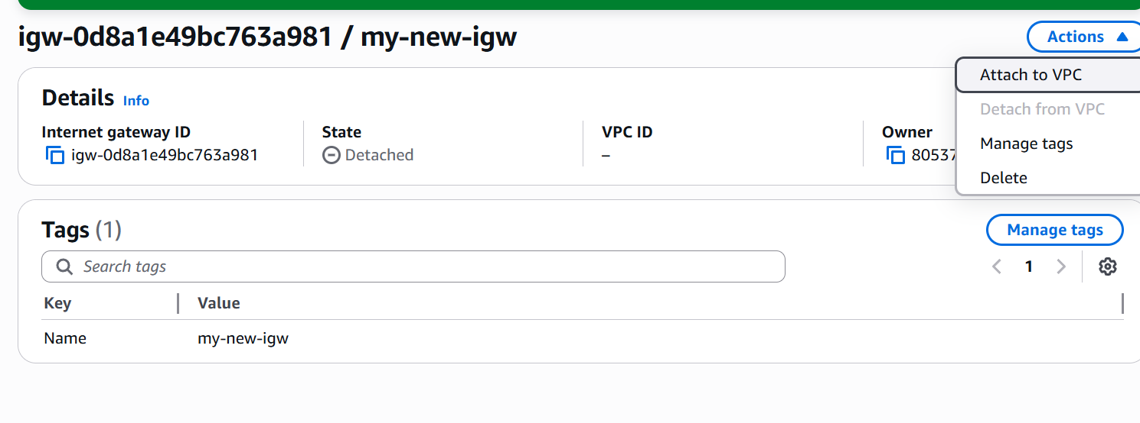
Click on actions then
Attach to VPC
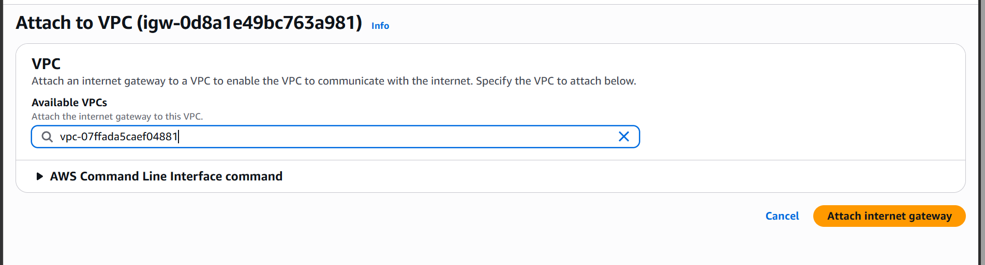

Now select our VPC
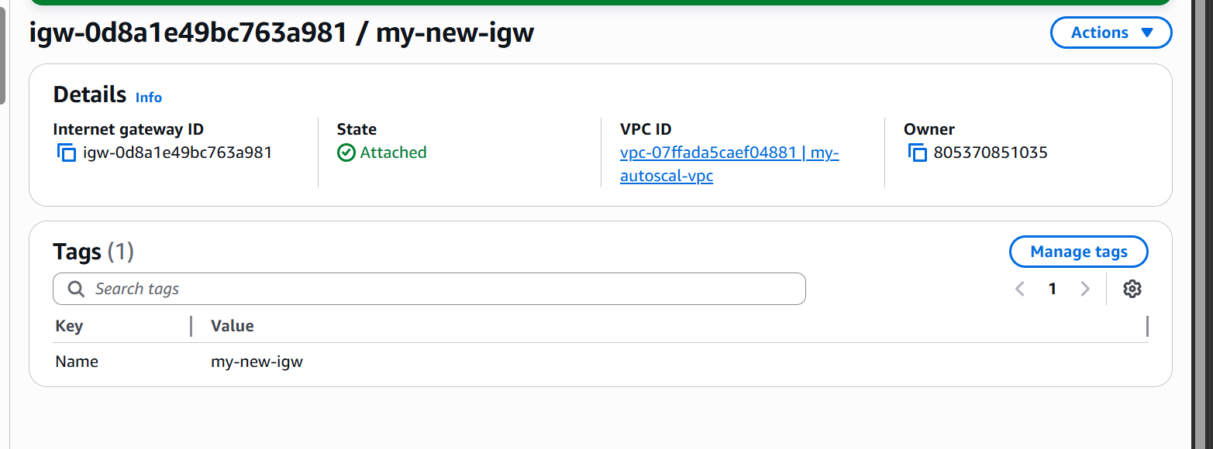

IGW is now attached to our VPC

Task04: Create one public and one private Route Table
Under VPC options click on route tables
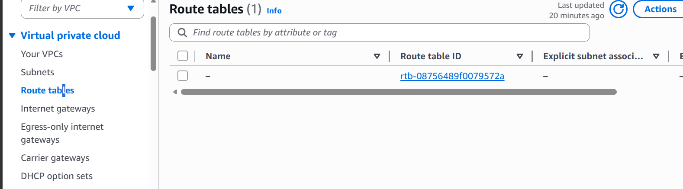
Click on create route table now
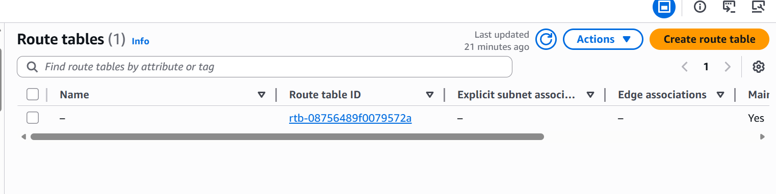
Give route table a name and select VPC
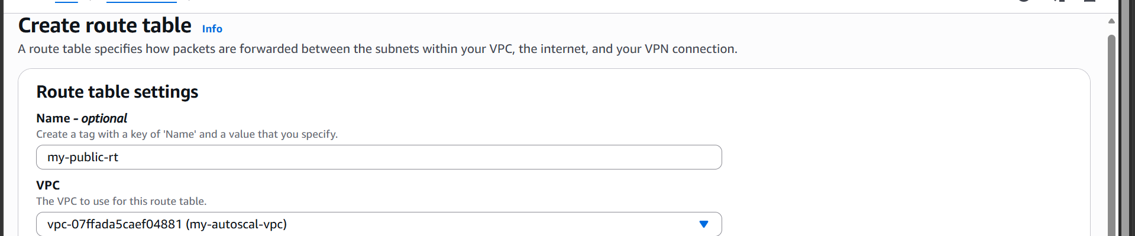
Now create route table
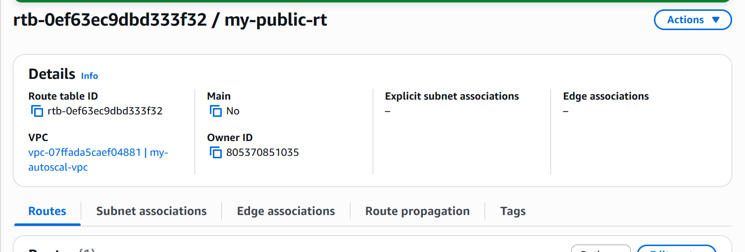
Associate this to a public subnet.
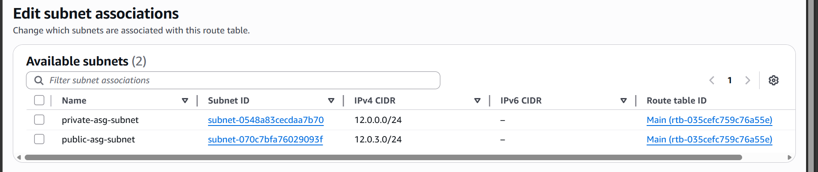

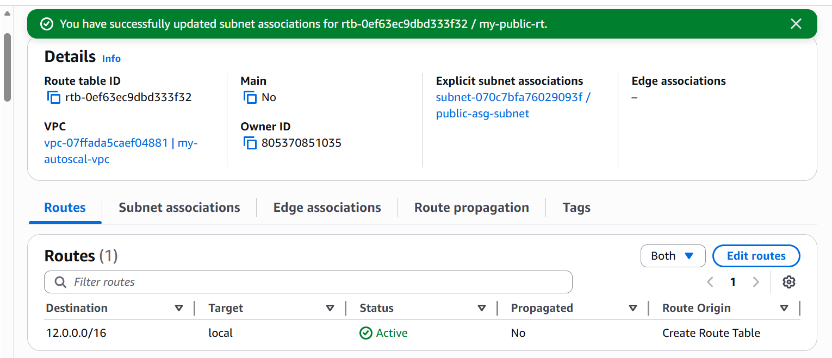
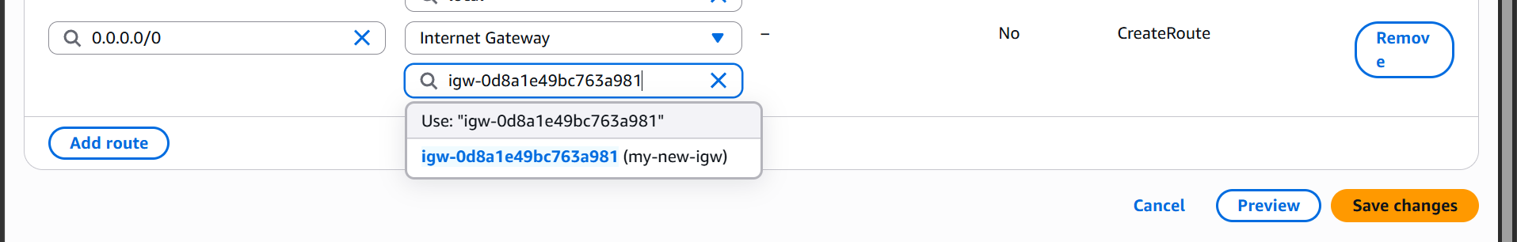

Attached internet gateway to public route table

We have attached our public route table to a public subnet

Let us now create a private route table
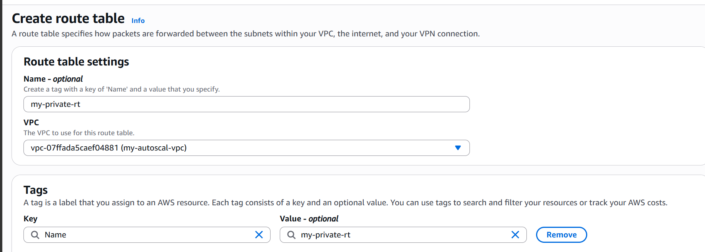
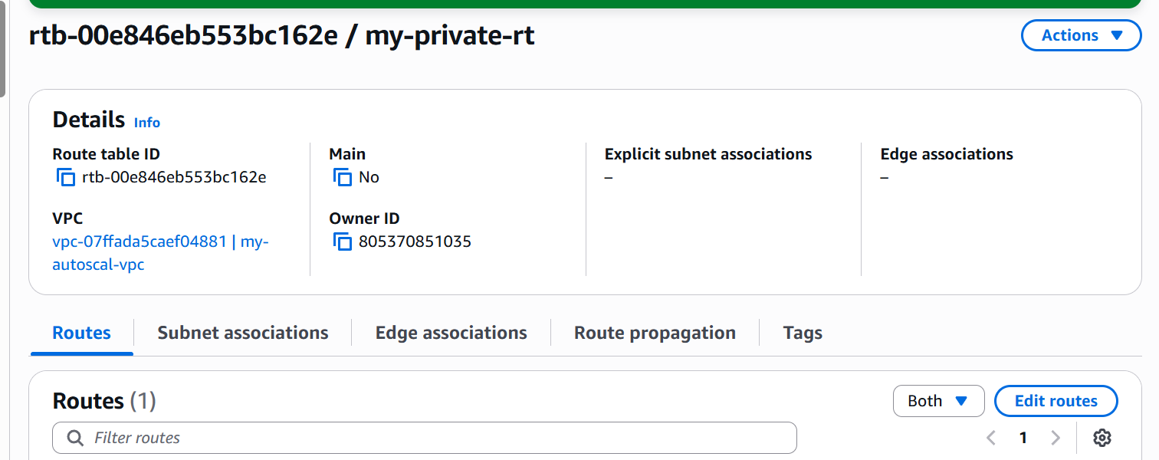

The private route table is now created let us now attach it to a private subnet by clicking on subnet associations
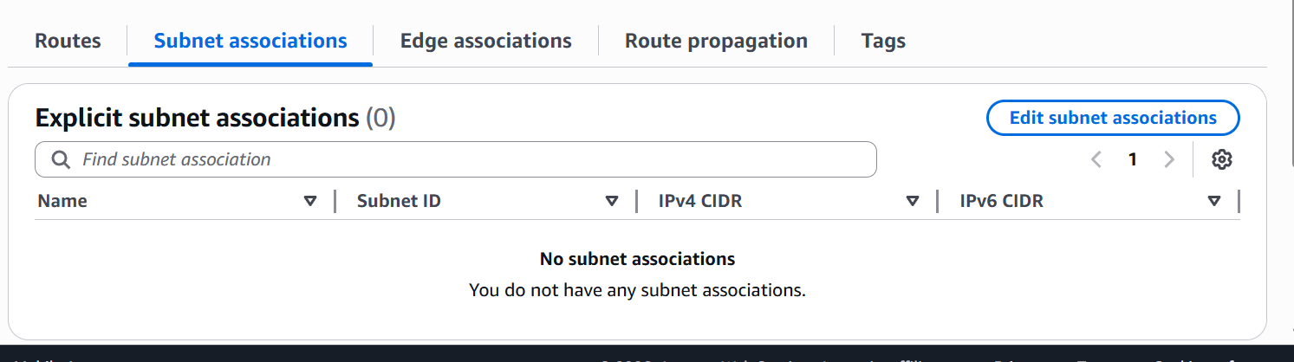

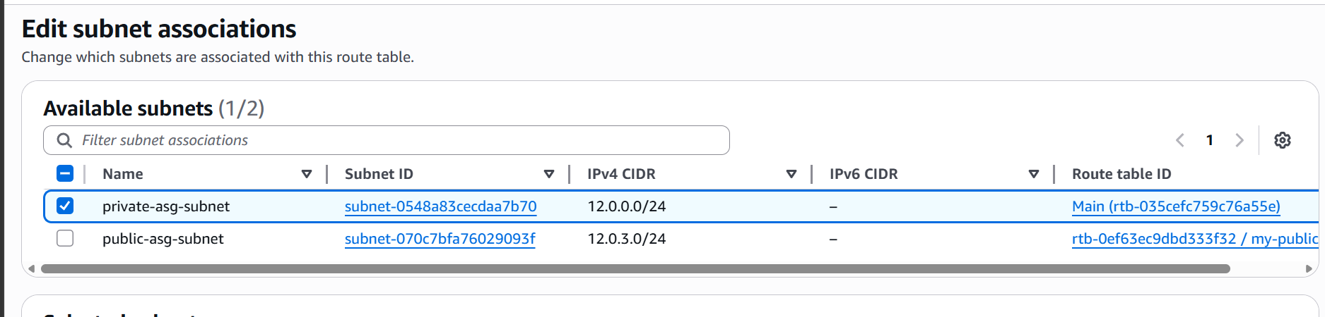

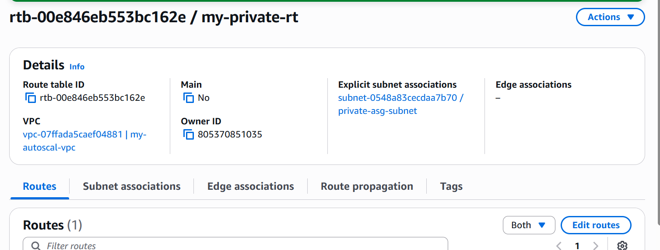

The route table is now attached to private subnet

Task05: Deploy a NAT gateway in public subnet and attach the nat gateway to private subnet.
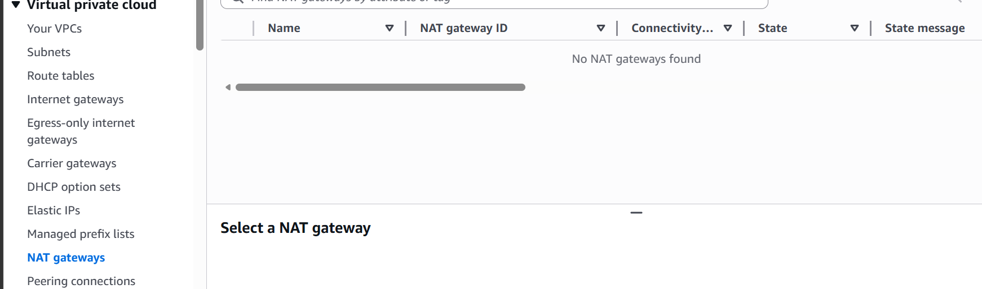
Go to NAT gateway section under the VPC options
Click on create NAT gateway
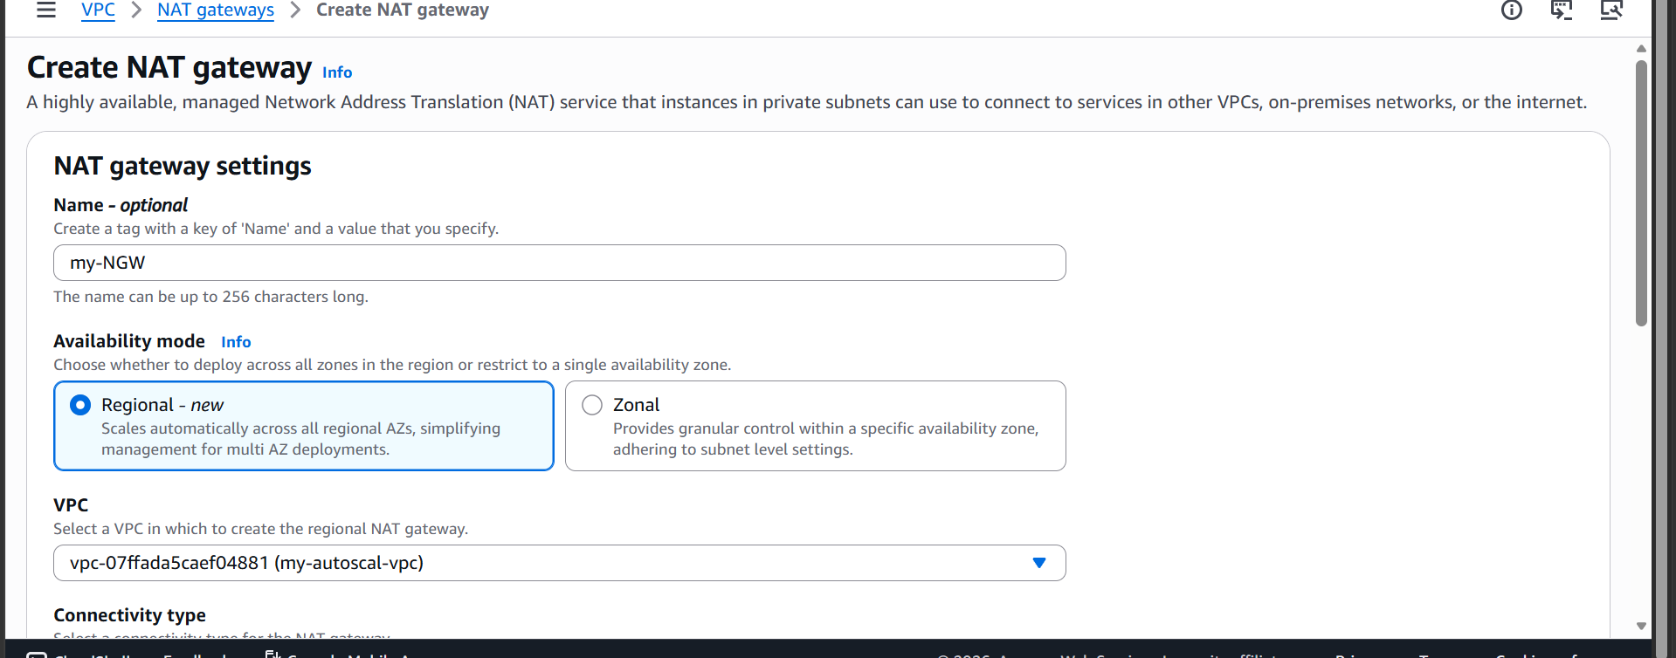

Give a name and attach it to vpc and then click on create
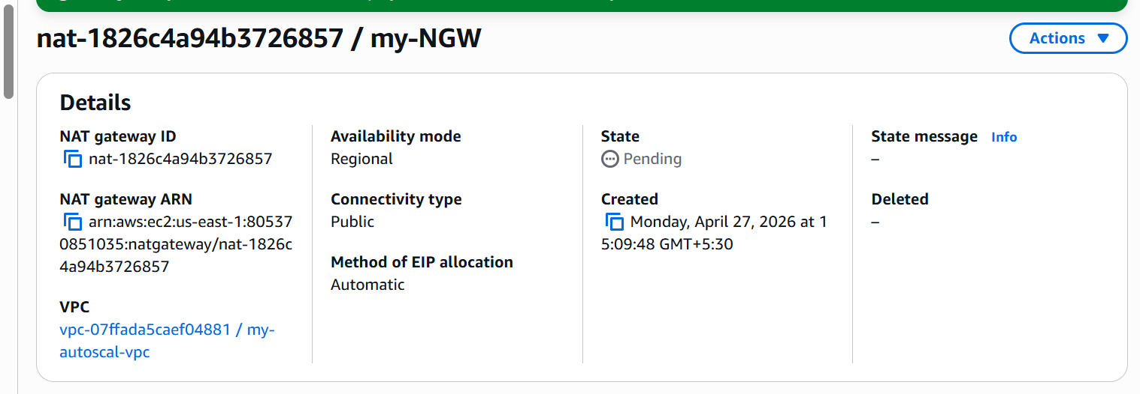
NAT gateway is created and is in pending state.
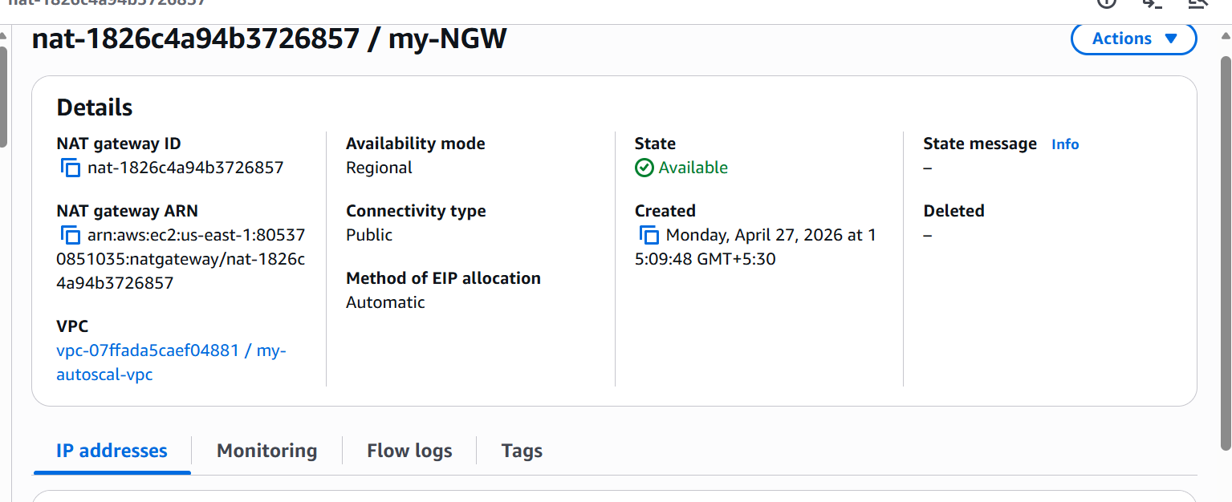

The NAT gateway is now in available state
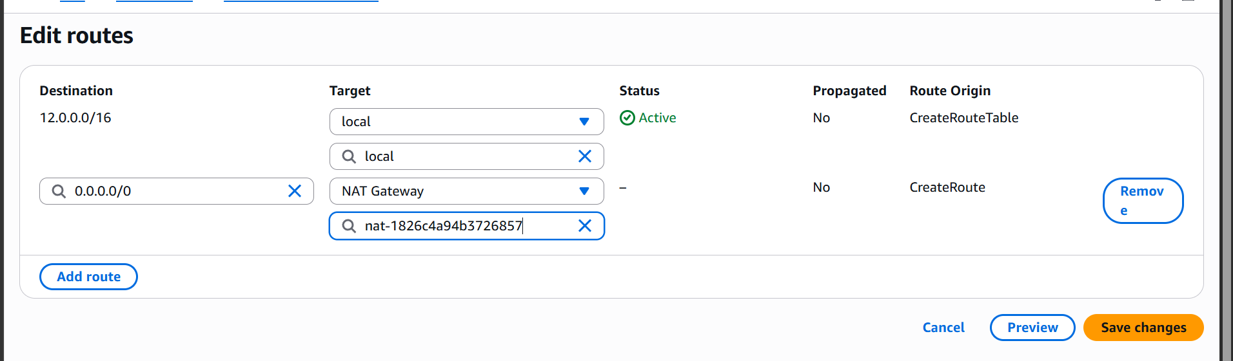

Let us attach it to private route table
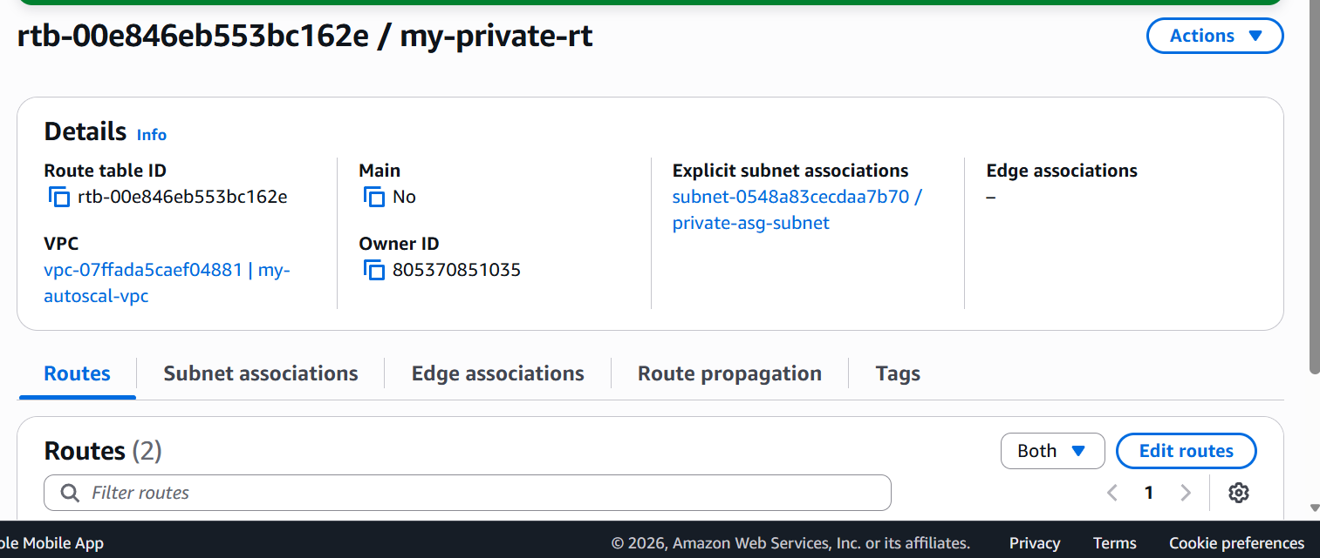
It is now attached to private subnet

Task06: Create one instance in public subnet and one in private subnet

Lets now launch two instances one in public and one in private
Go to EC2 service

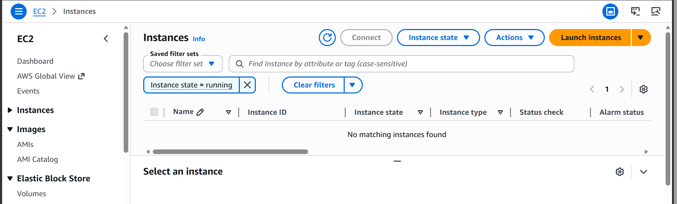

Click on launch instance
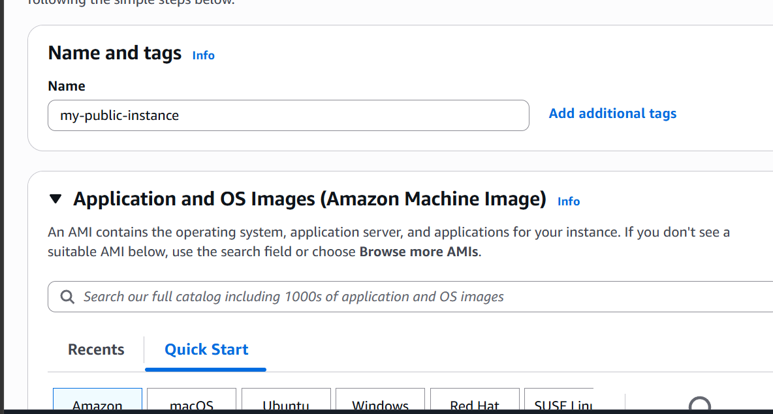

Give it a name and select key pair
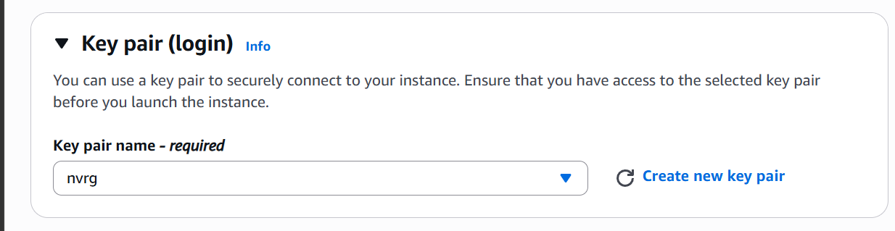

In network settings click on edit and select our vpc and select public subnet

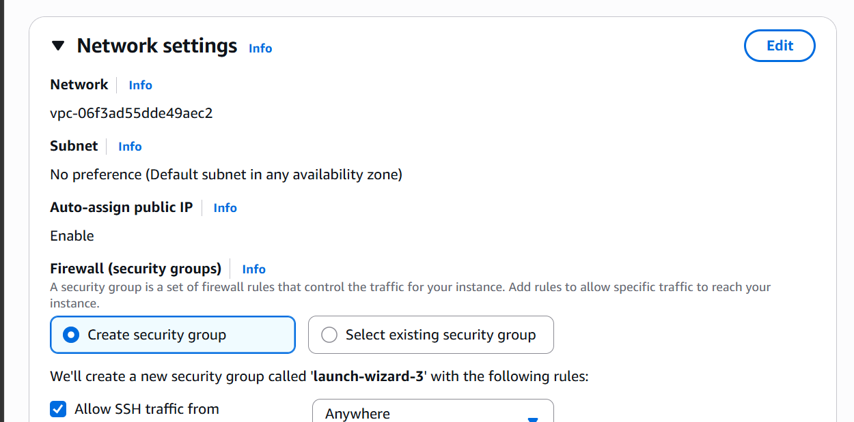
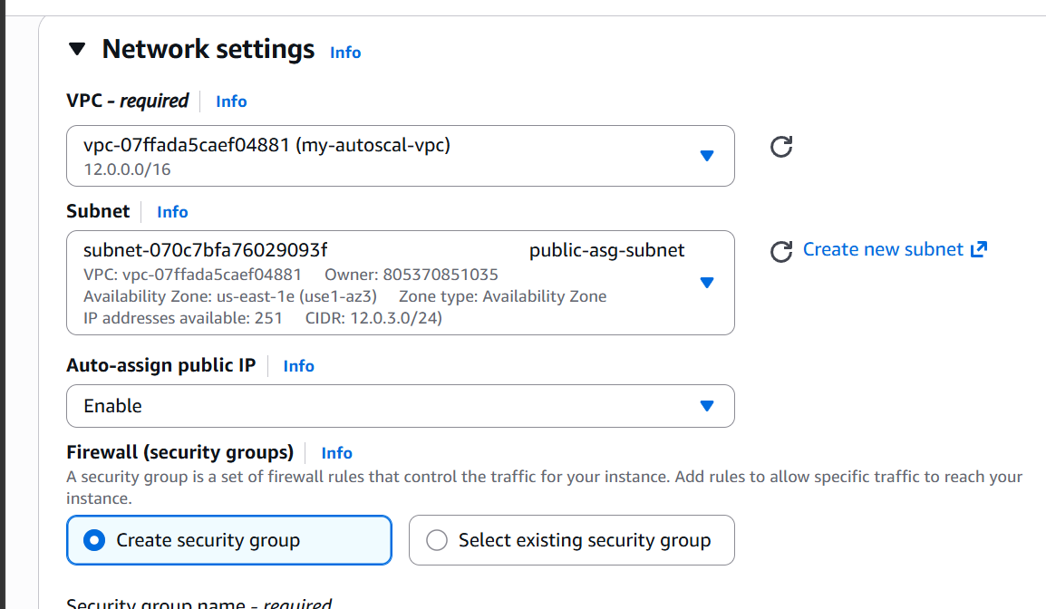

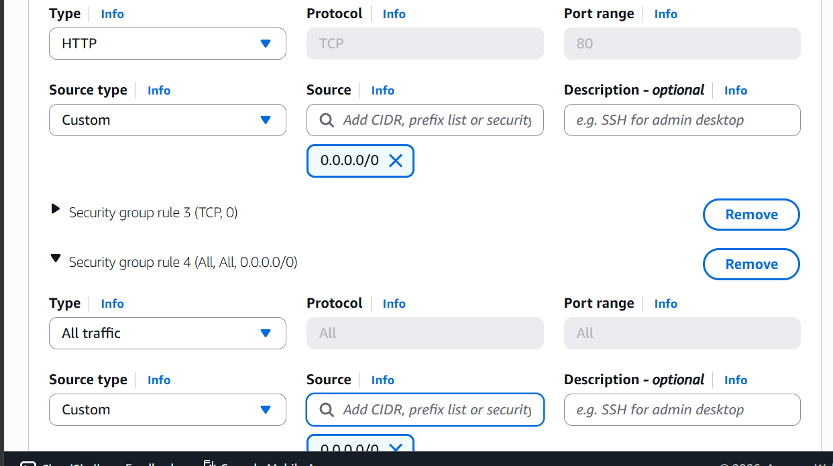
Allow HTTP and All traffic to check connectivity
Now click on launch instance
This is a public instance that we have created.
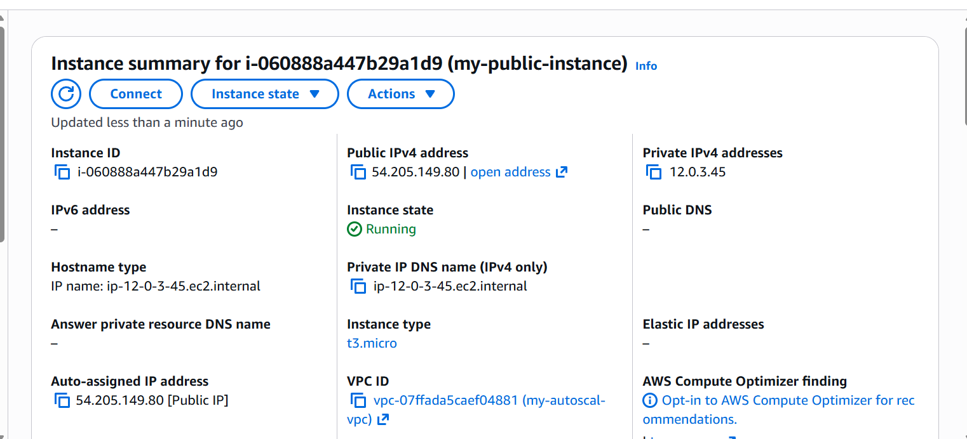

Now let us launch one private instance
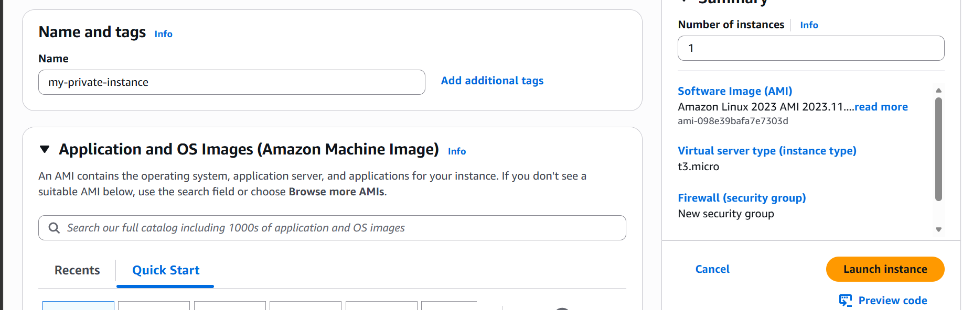

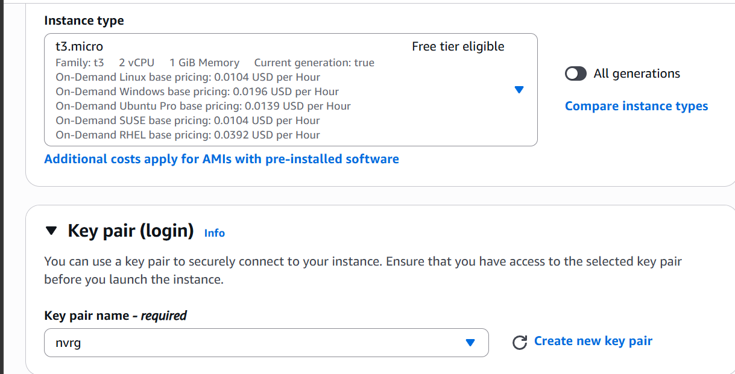

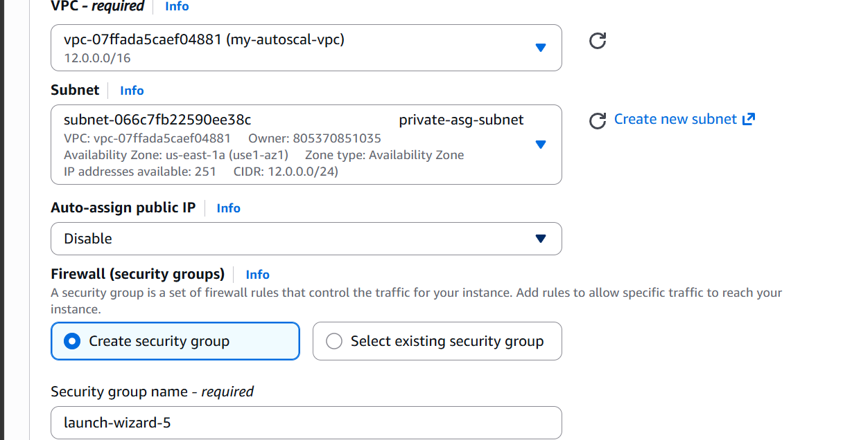
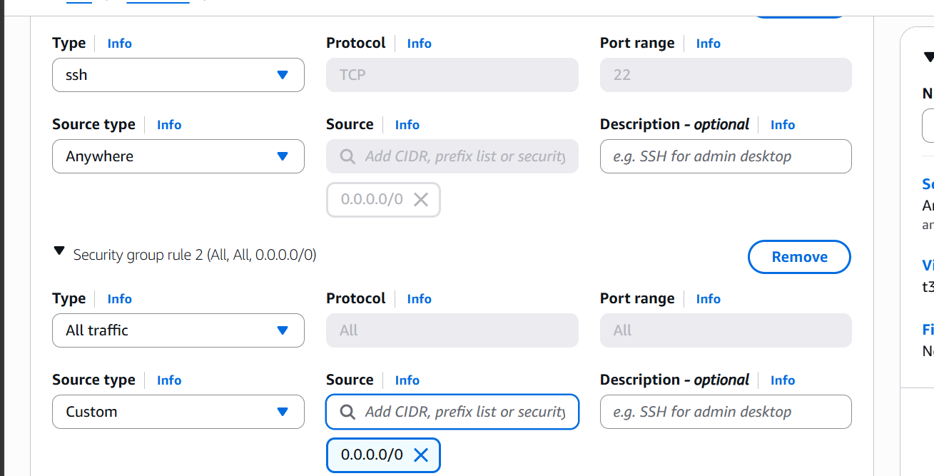

We have ssh to our public instance and we are able to ping to our instance in private subnet

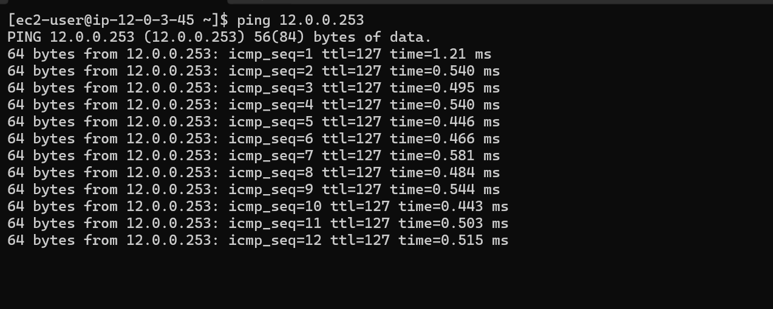

Task06: Deploy apache server on ec2 instance with a sample index.html file
First let us do in public subnet
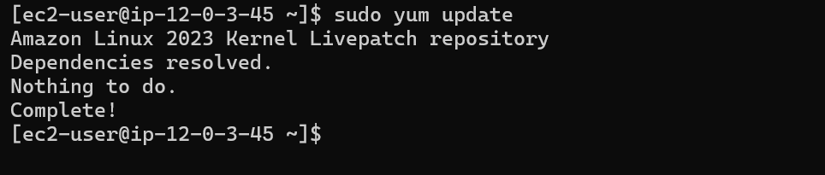
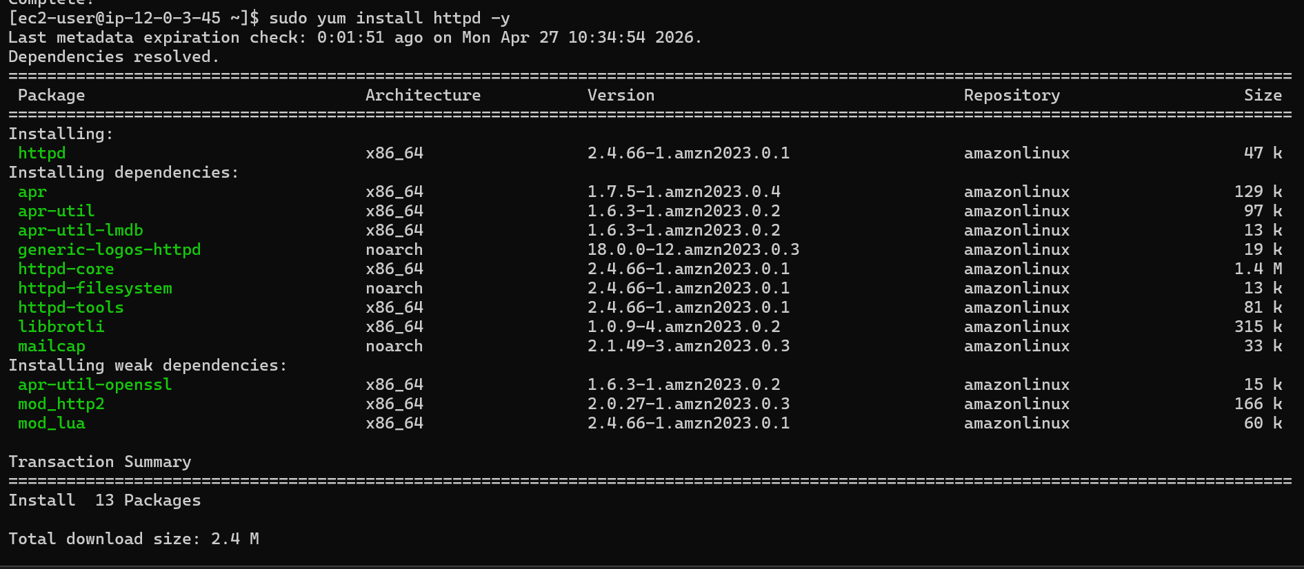
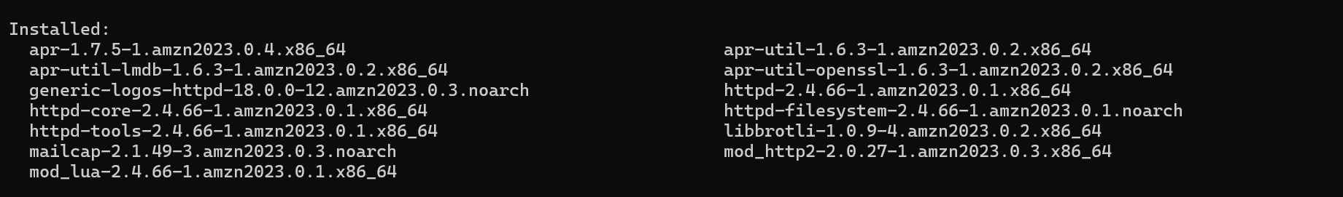

Go to /var/www/html
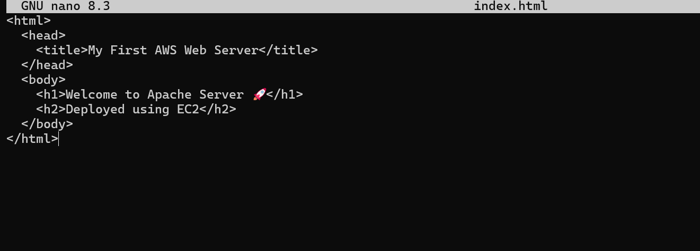
Add index.html file
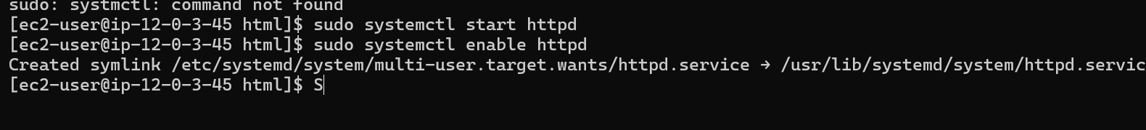
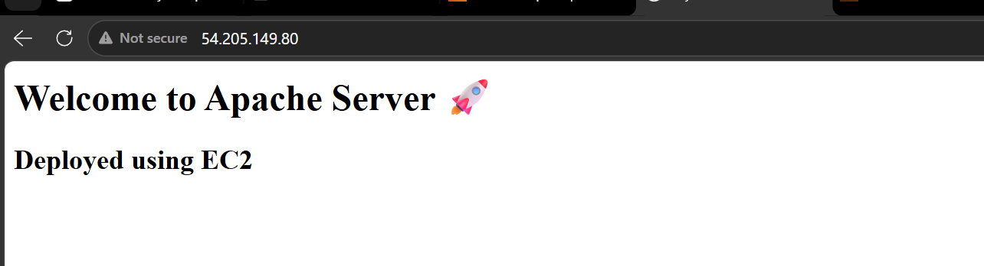

We are now able to access our website

Let us now deploy in private instance
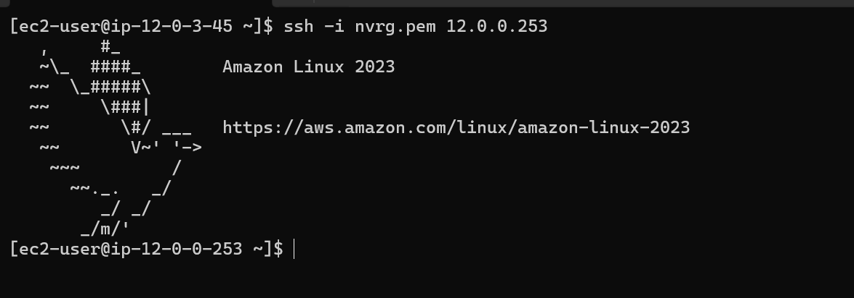

We are into our private instance now
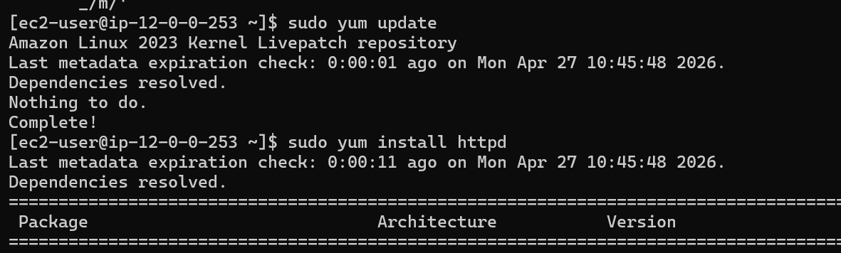
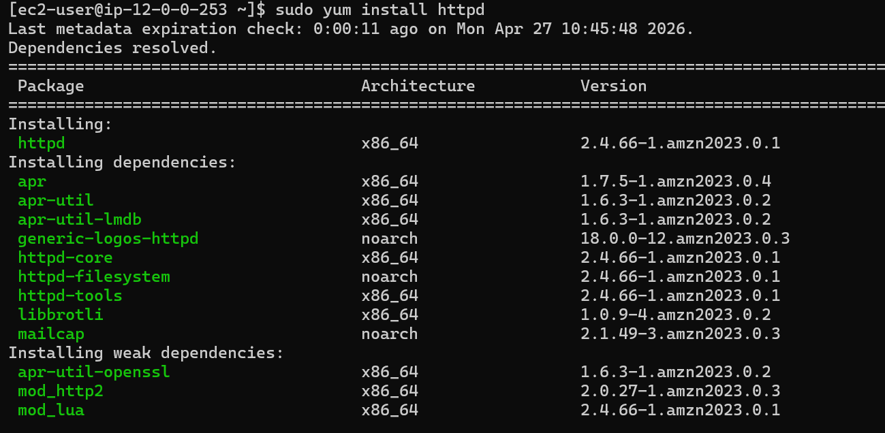
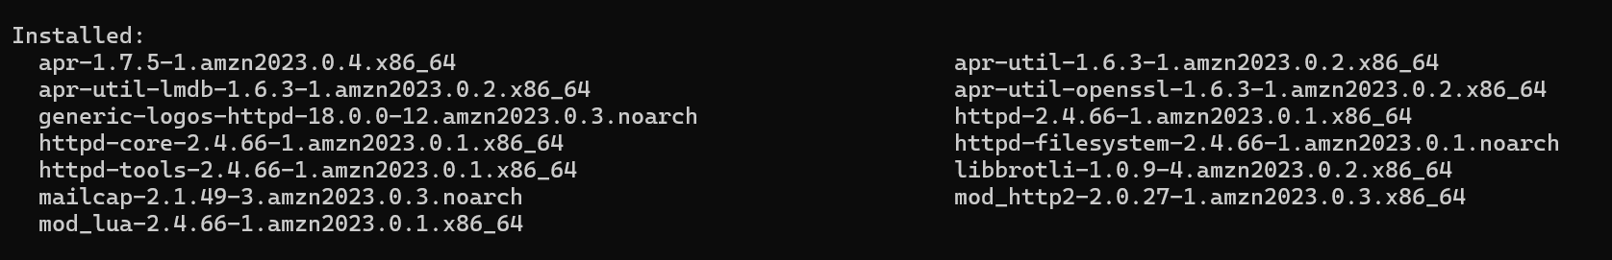
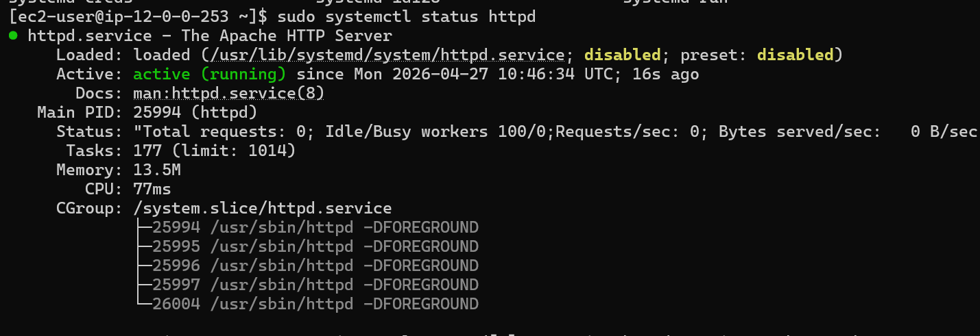

The httpd service is now running
Lets go now to /var/www/html location and deploy our static page
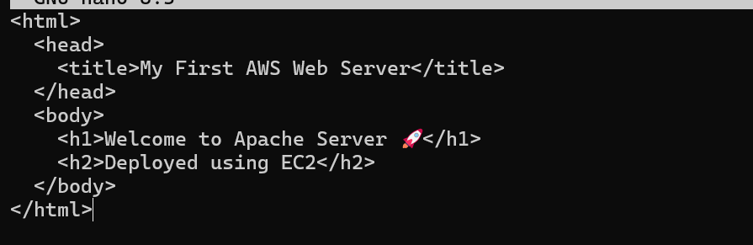
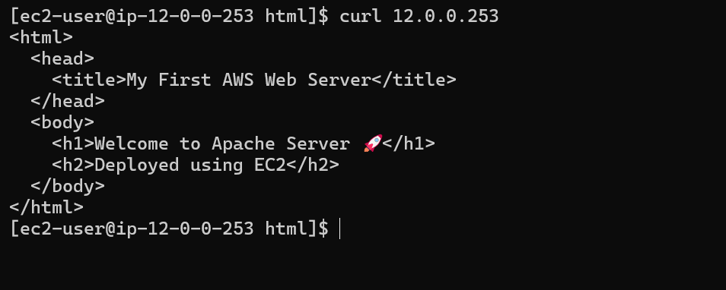
Our static website is now working in private instance as well.

Task08: Create one application load balancer and attach it to both EC2 instances.
Lets go to ec2 and select load balancer
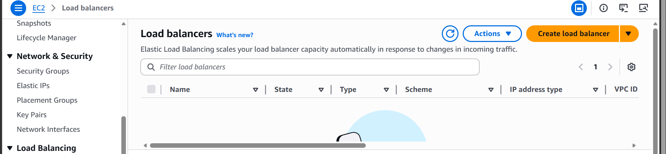
Click on create load balancer
Select application load balancer
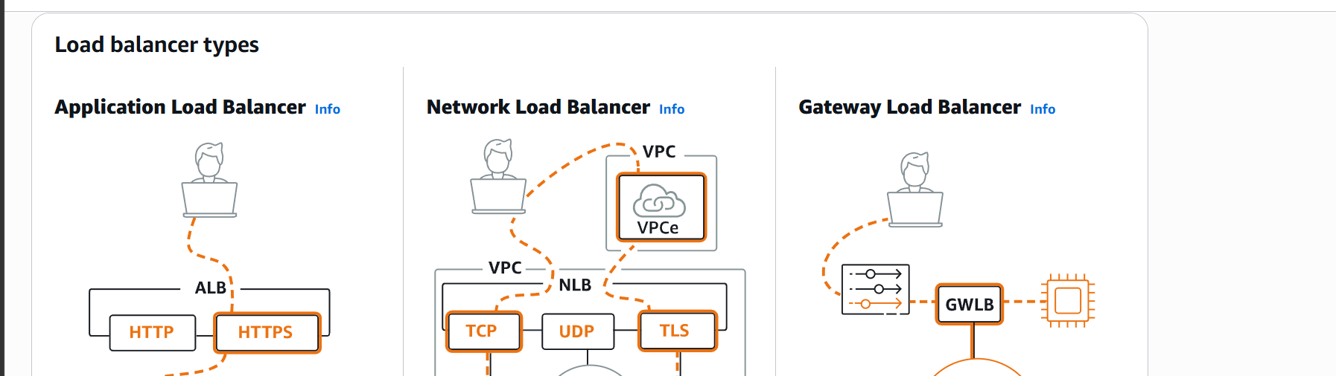
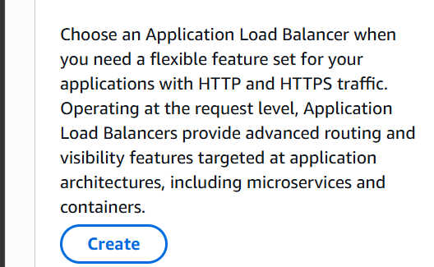

Give it a name and select internet facing
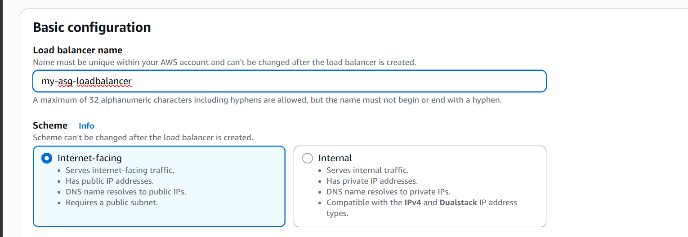
Select ipvd as IP address type
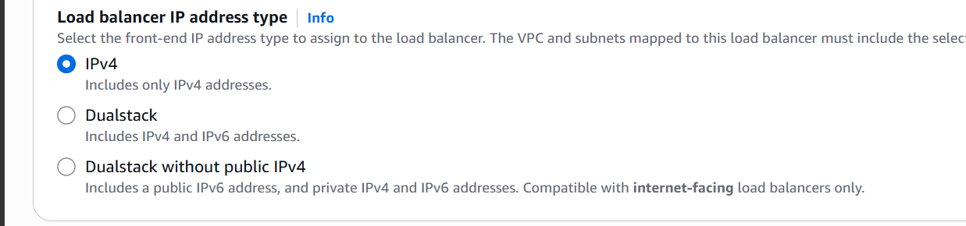

Select VPC
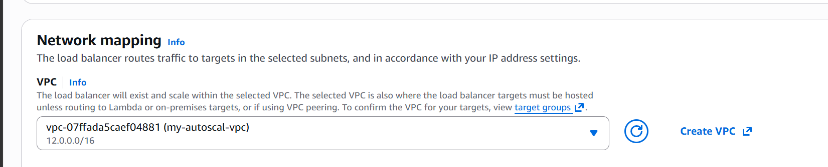

Now let us create a security group and give
Inbound 80
Outbound all traffic access.
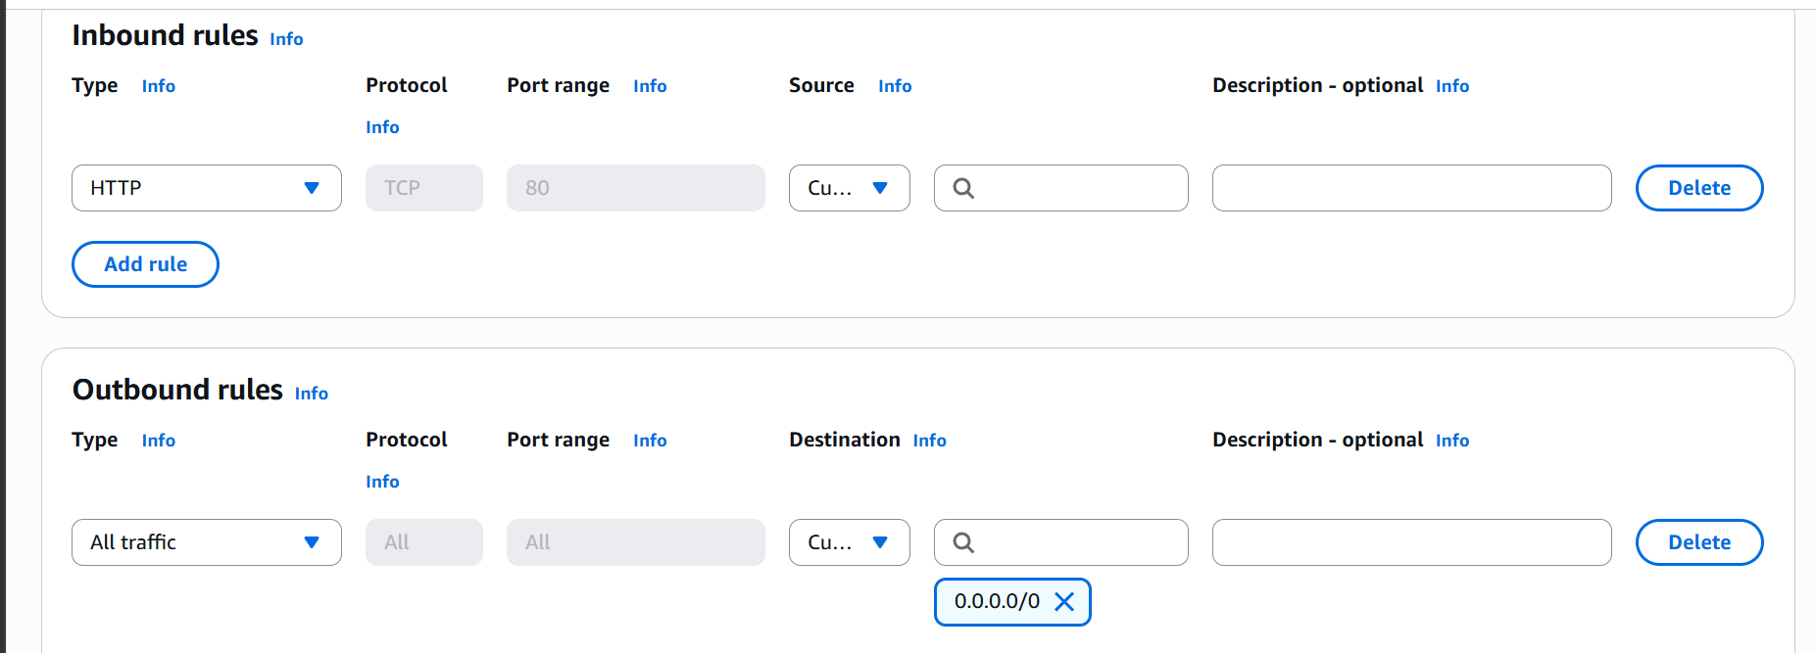

Now create a Target Group
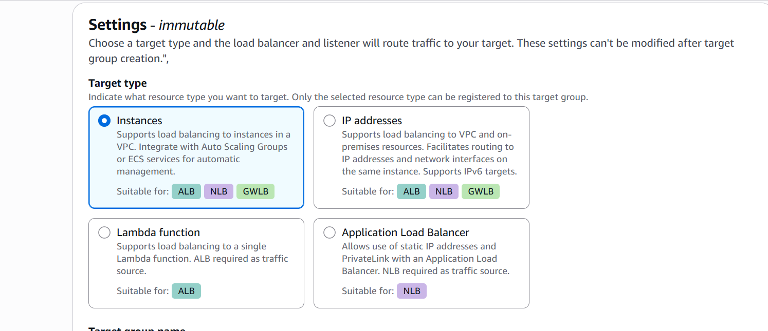
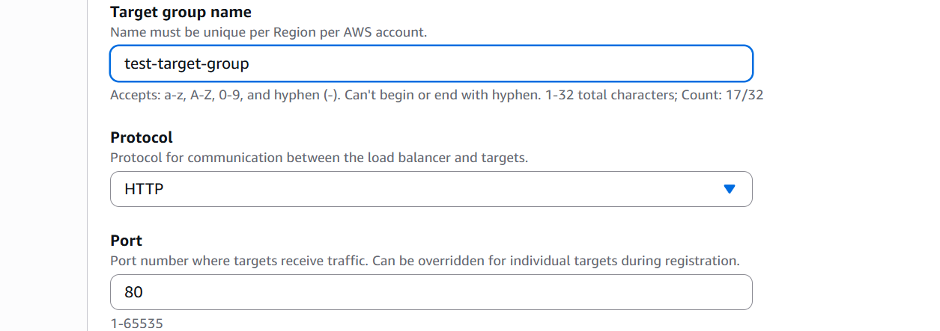
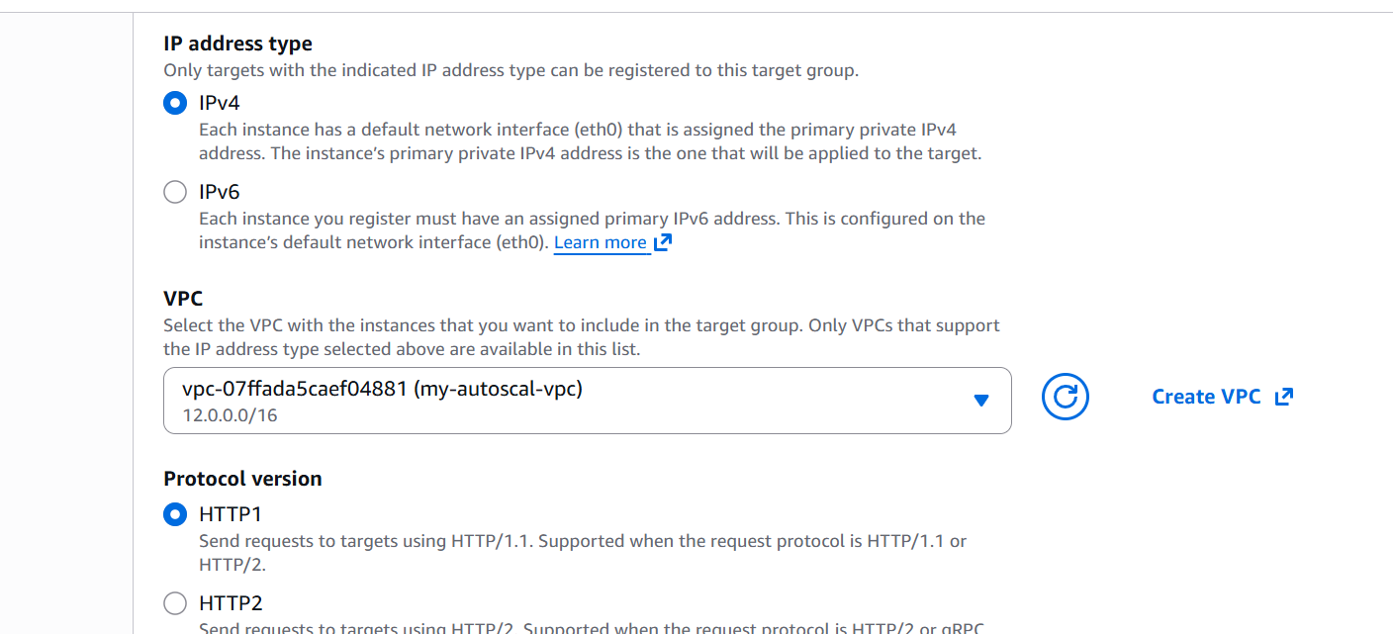
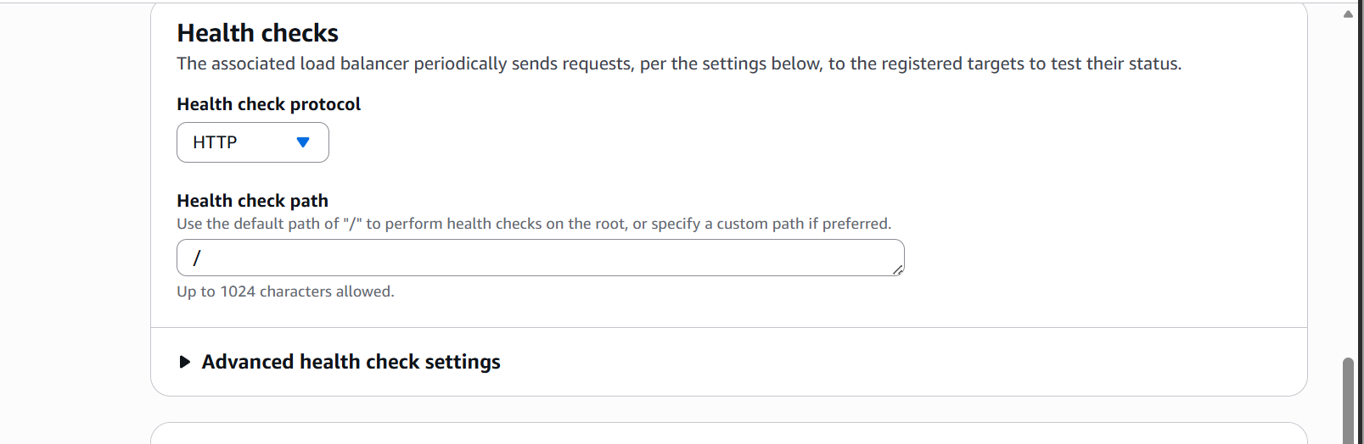
Selecting Targets
Both of our EC2 instances are targets
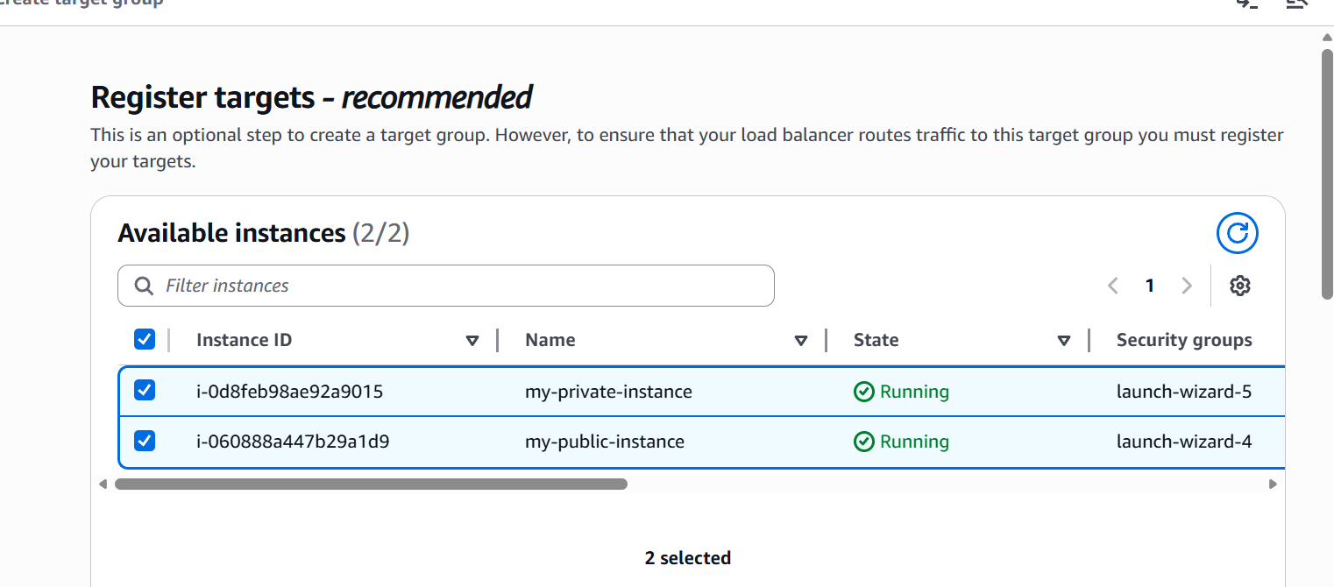

Click on create target group now
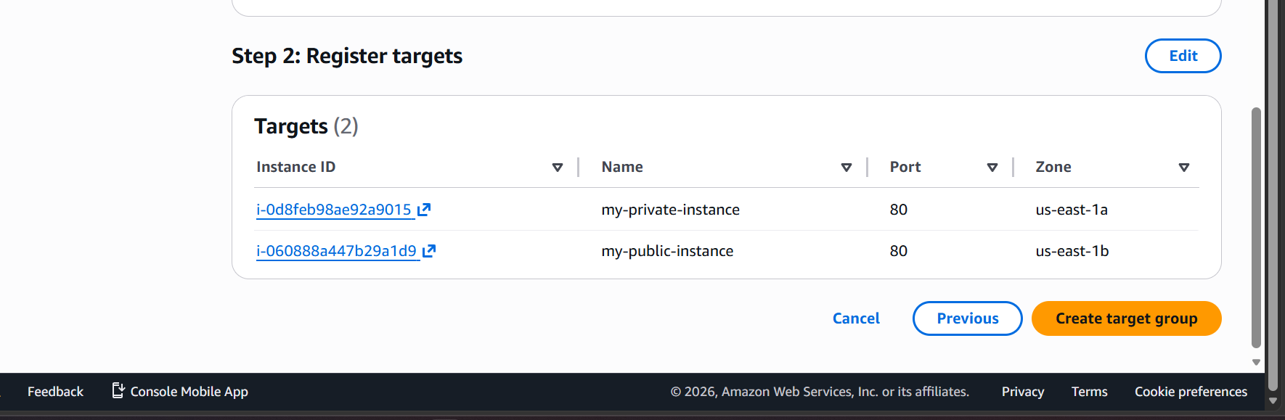
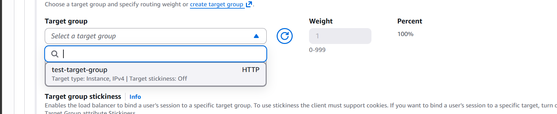

Now select our target group

Create Load Balancer
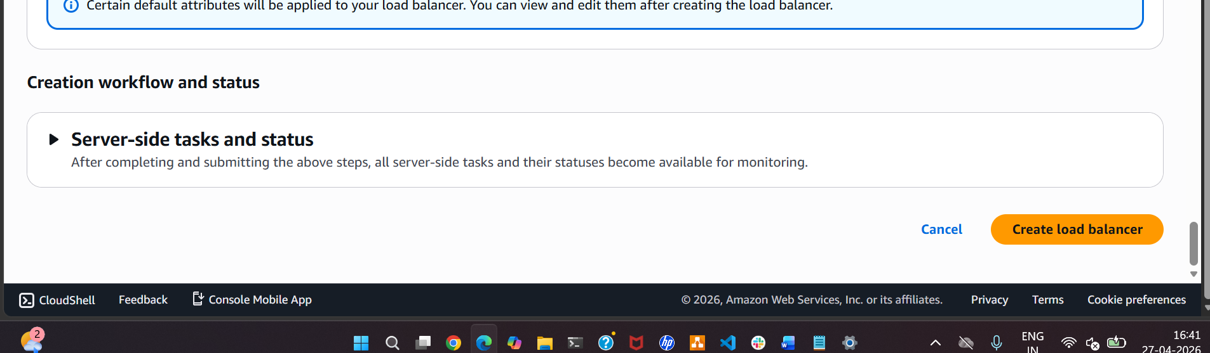

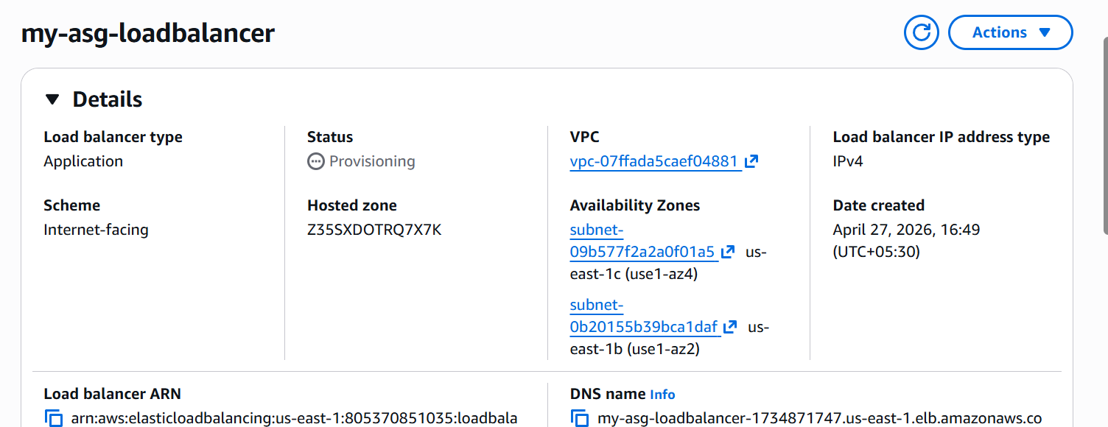

Now our load balancer is created
Lets wait till it becomes available
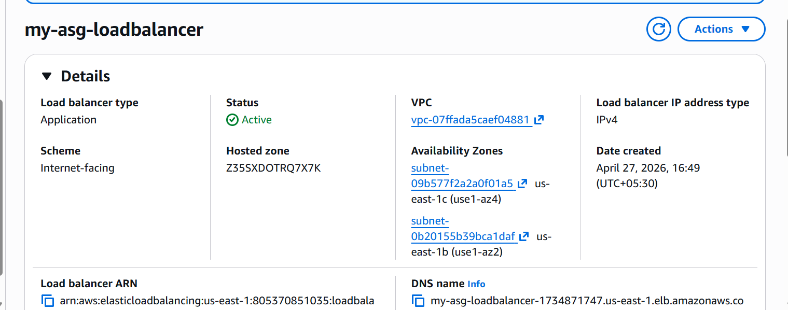
The load balancer is active now.

Task09: Store application load balancer logs in S3
Let us first create a S3 bucket
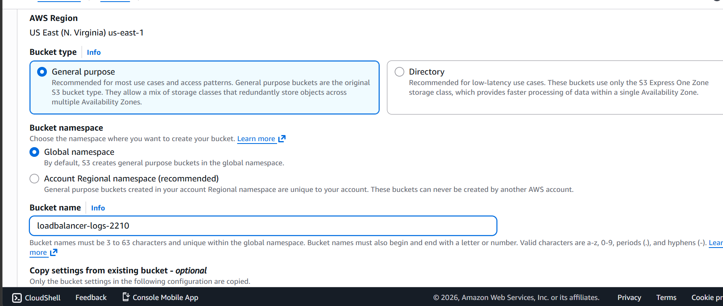

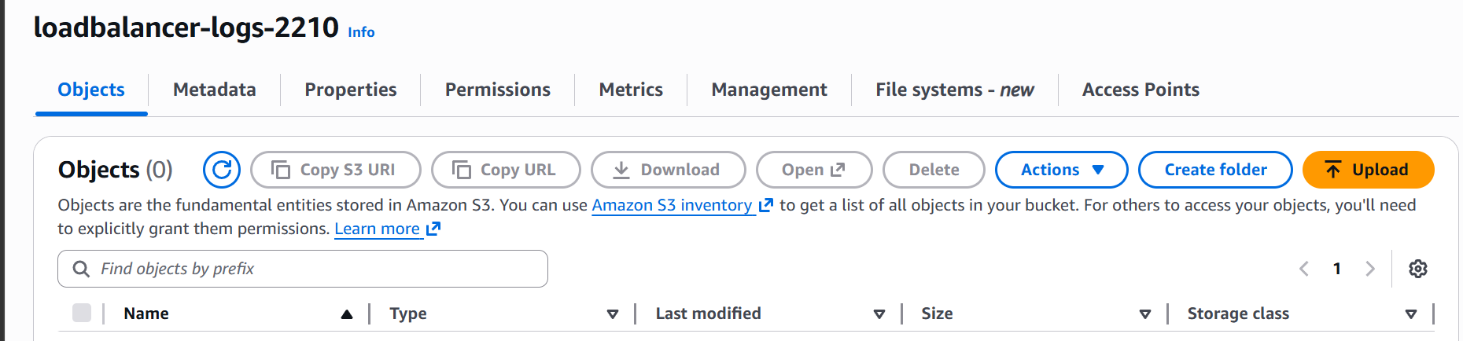

S3 bucket is now created lets now update the bucket policy
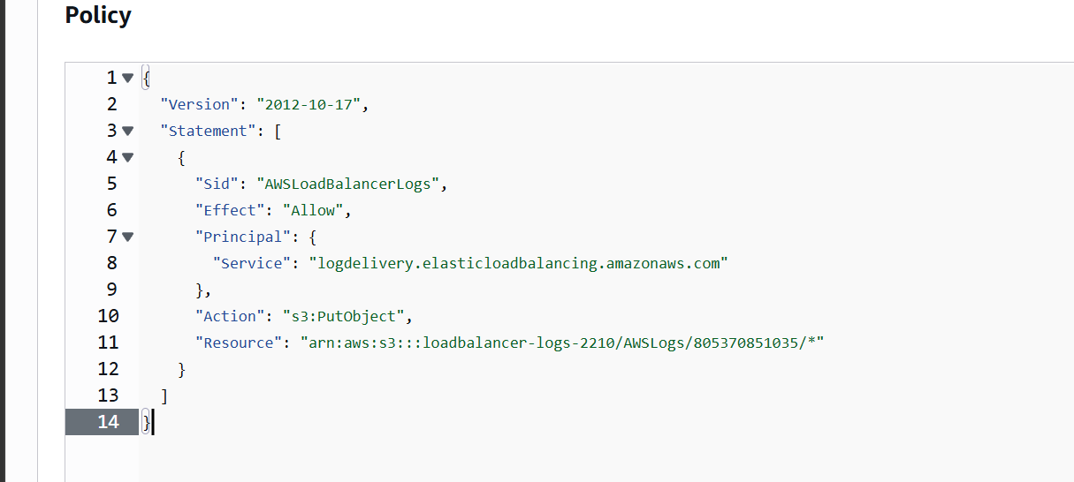

Now let us go to load balancers on enable logs
Go to attributes
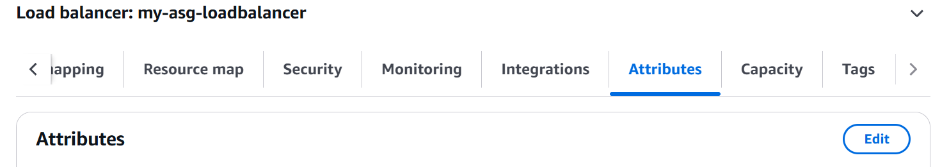
Click on edit
Go down to monitoring section and select our s3 bucket
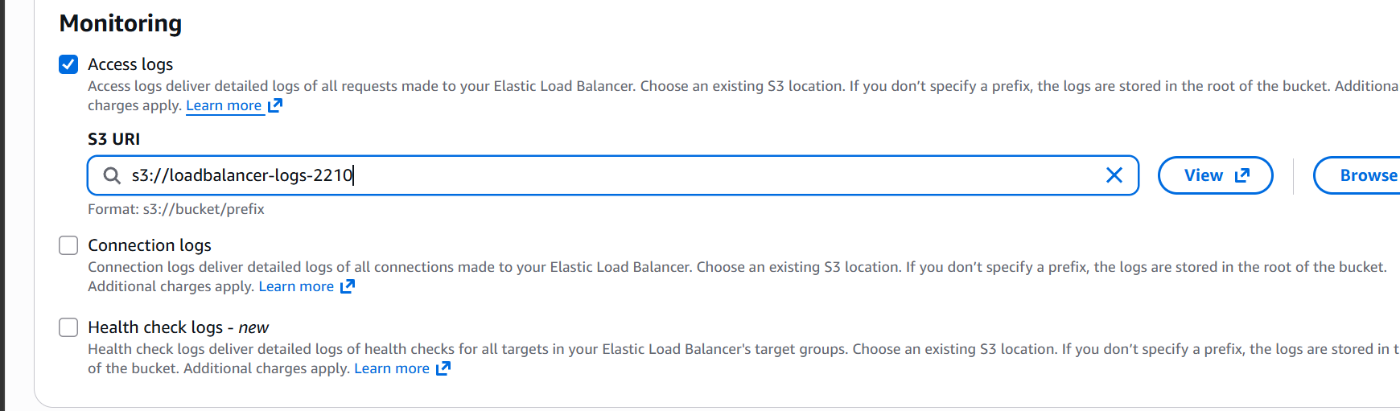

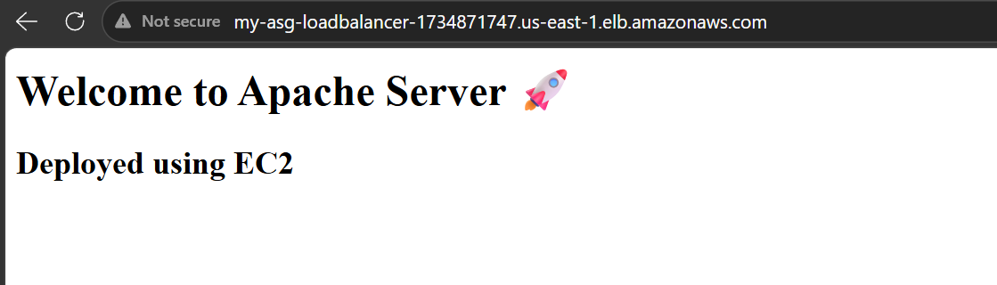
We are now able to access our static website by load balancer dns

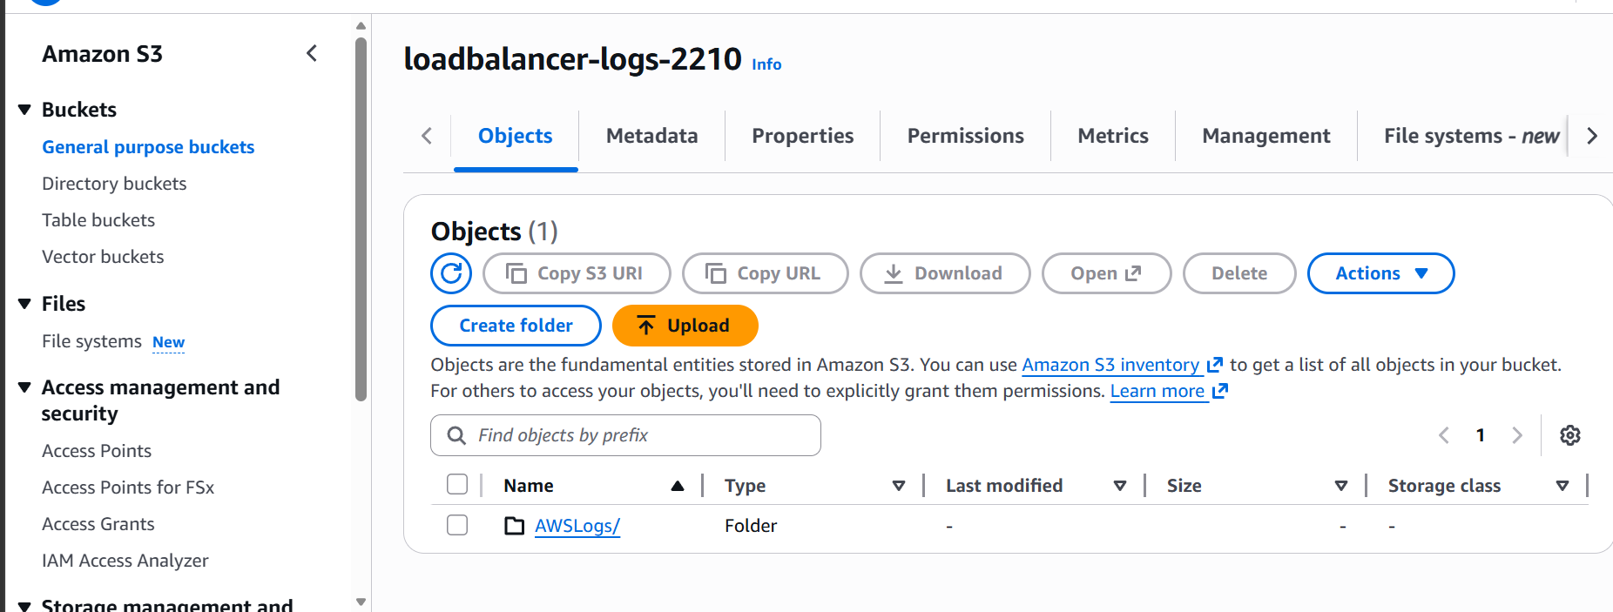

Now we can see the logs of the ALB as well

Task10: Store the VPC flow logs in Cloud Watch Log Group
Go to the VPC
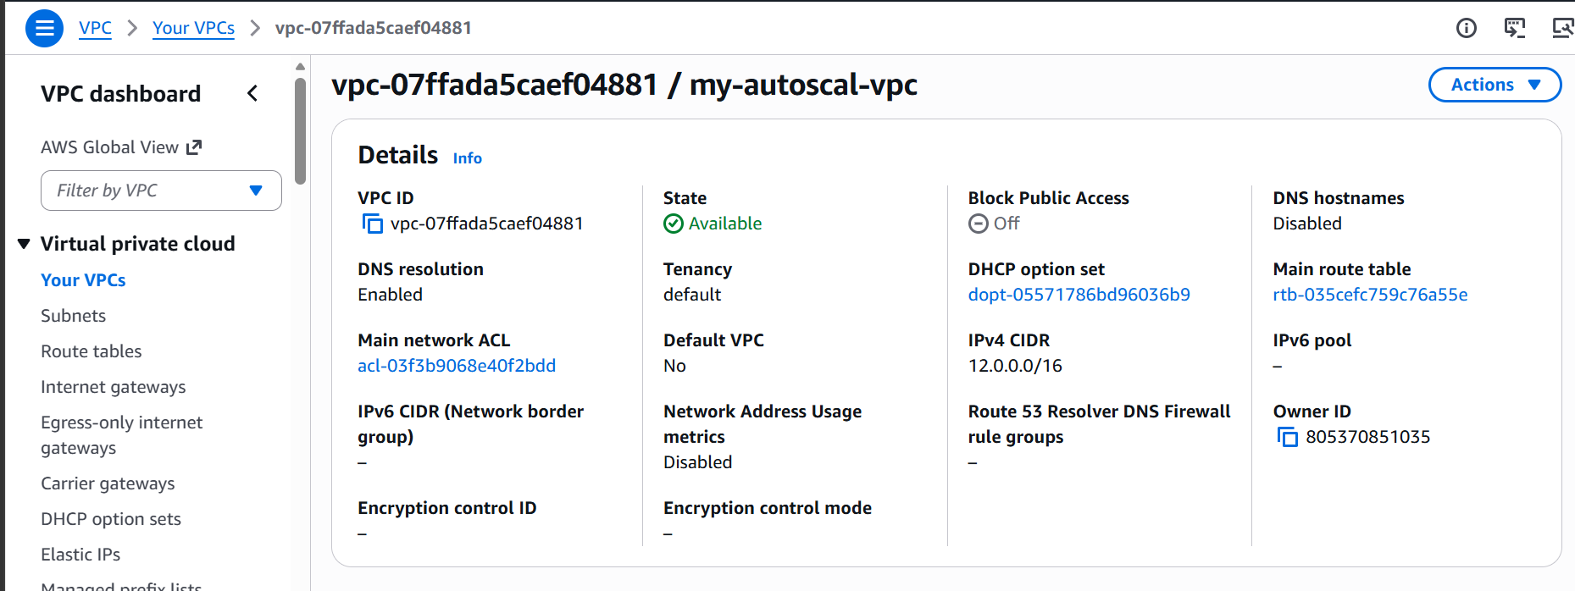
Click on actions
Then click on create flow log
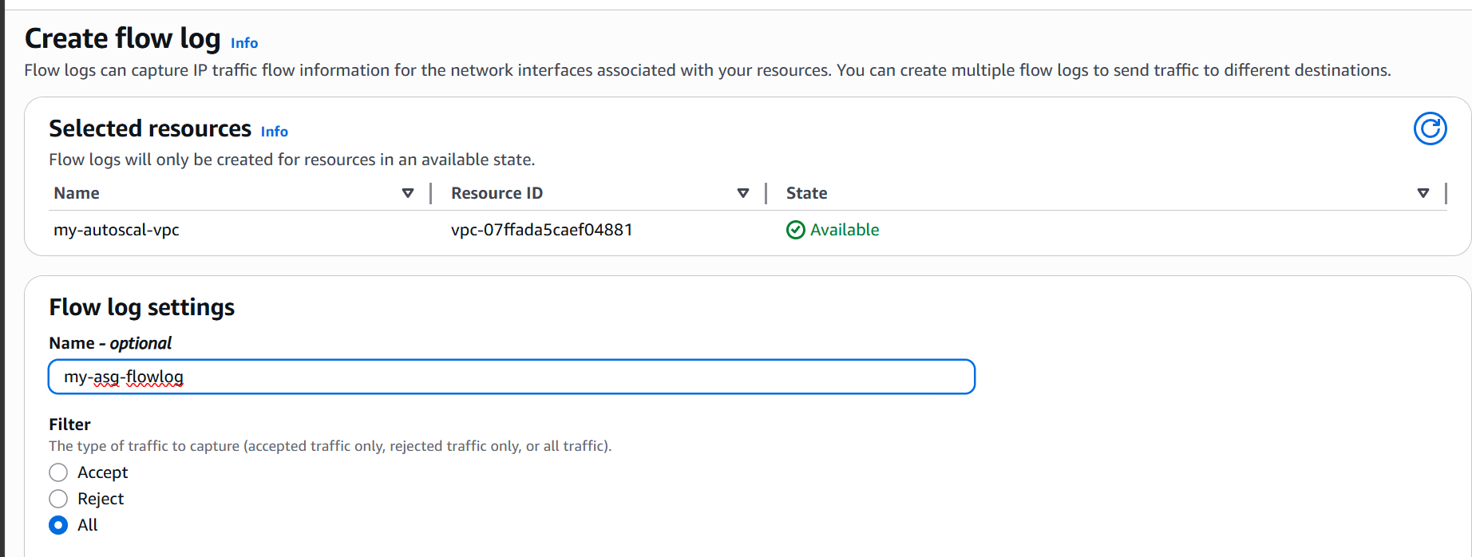

Give a name
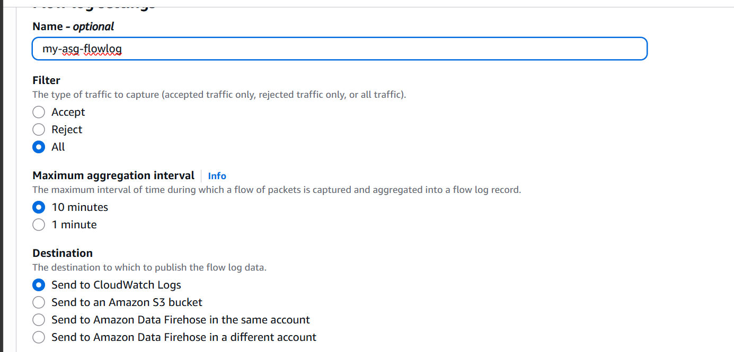
Type of traffic all and send to cloudwatch logs
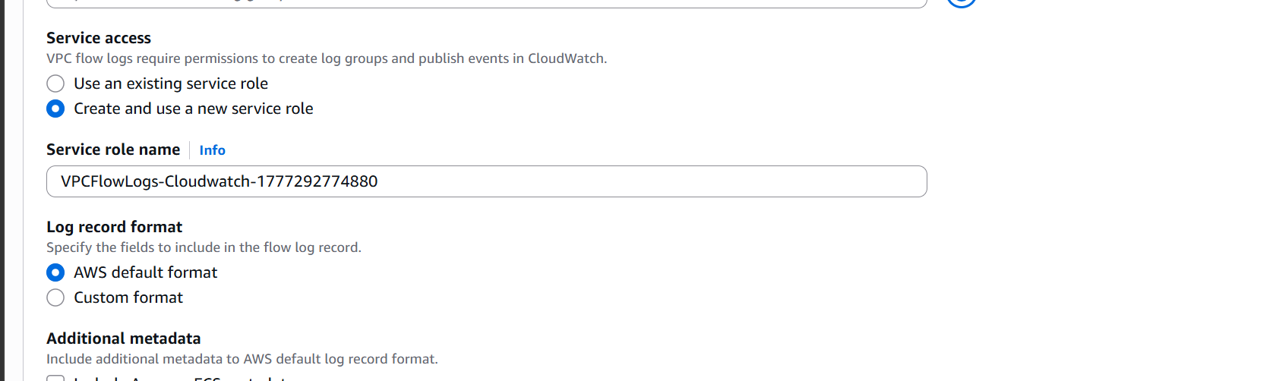
Create and use a new service role

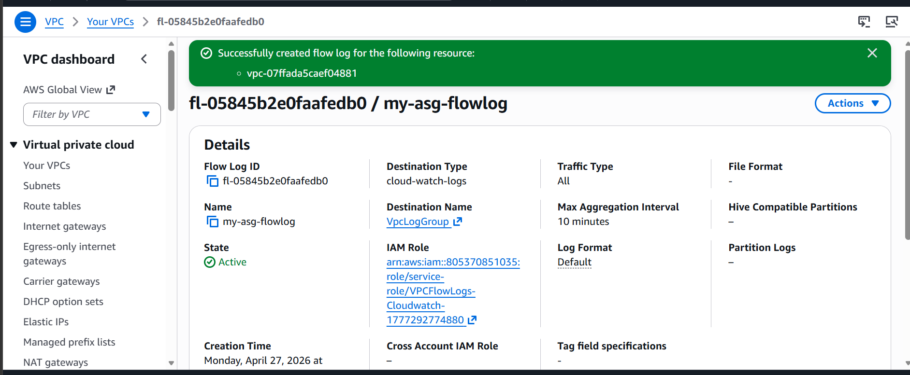

Flow log is now created

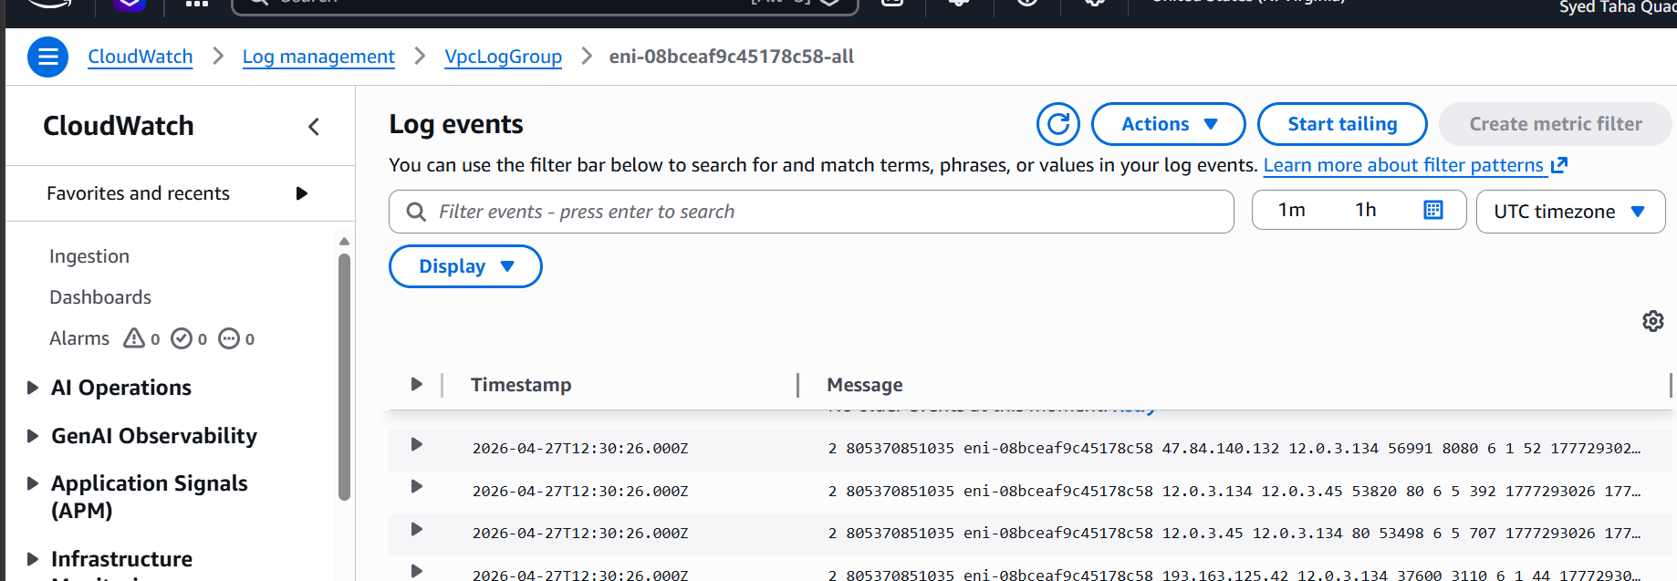

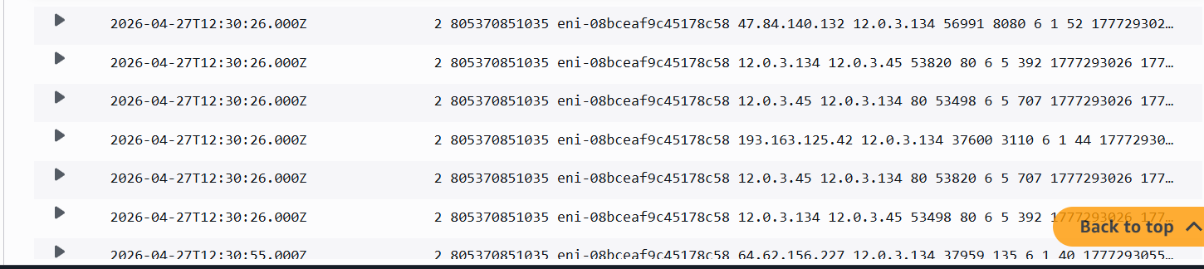

Logs are updated as well.

Task11: Create monitoring dashboards to monitor CPU utilization and to monitor the Apache service.
First go to the cloudwatch service
And create a dashboard
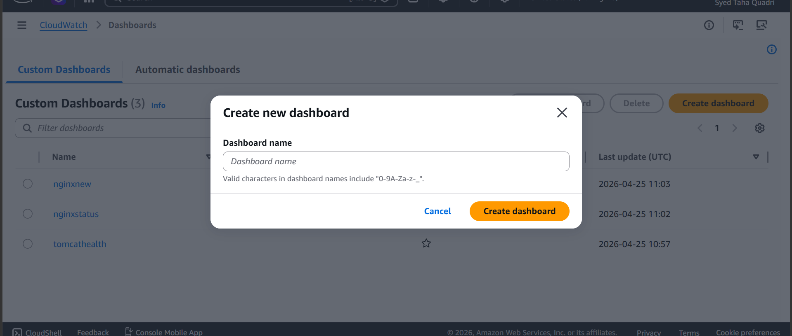

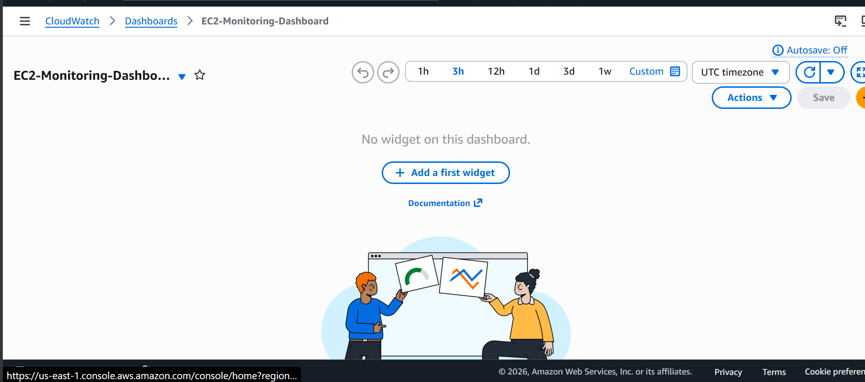
Dashboard is created now add a widget
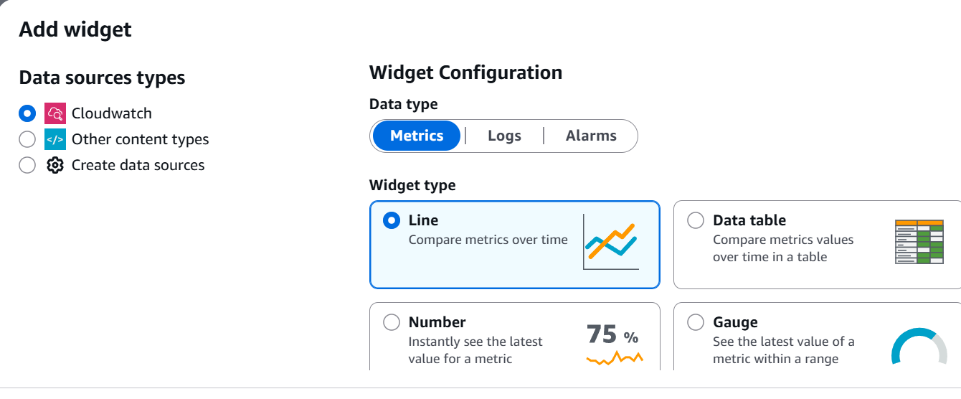
Next select EC2 and per instance metrics
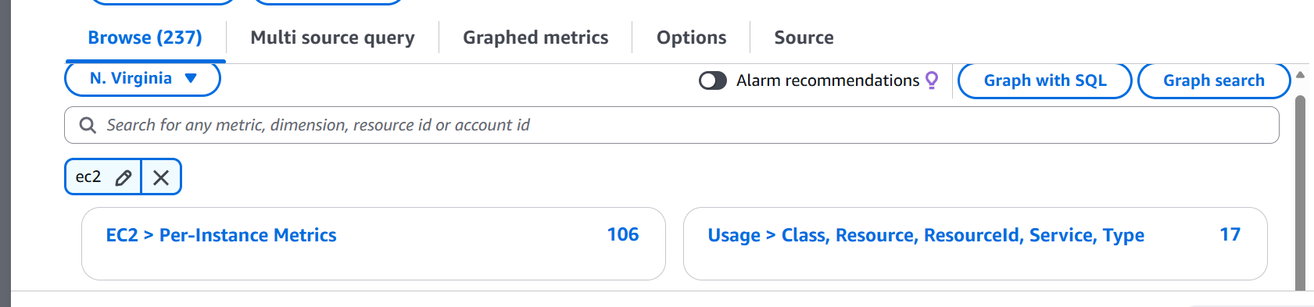
Selecting our instances
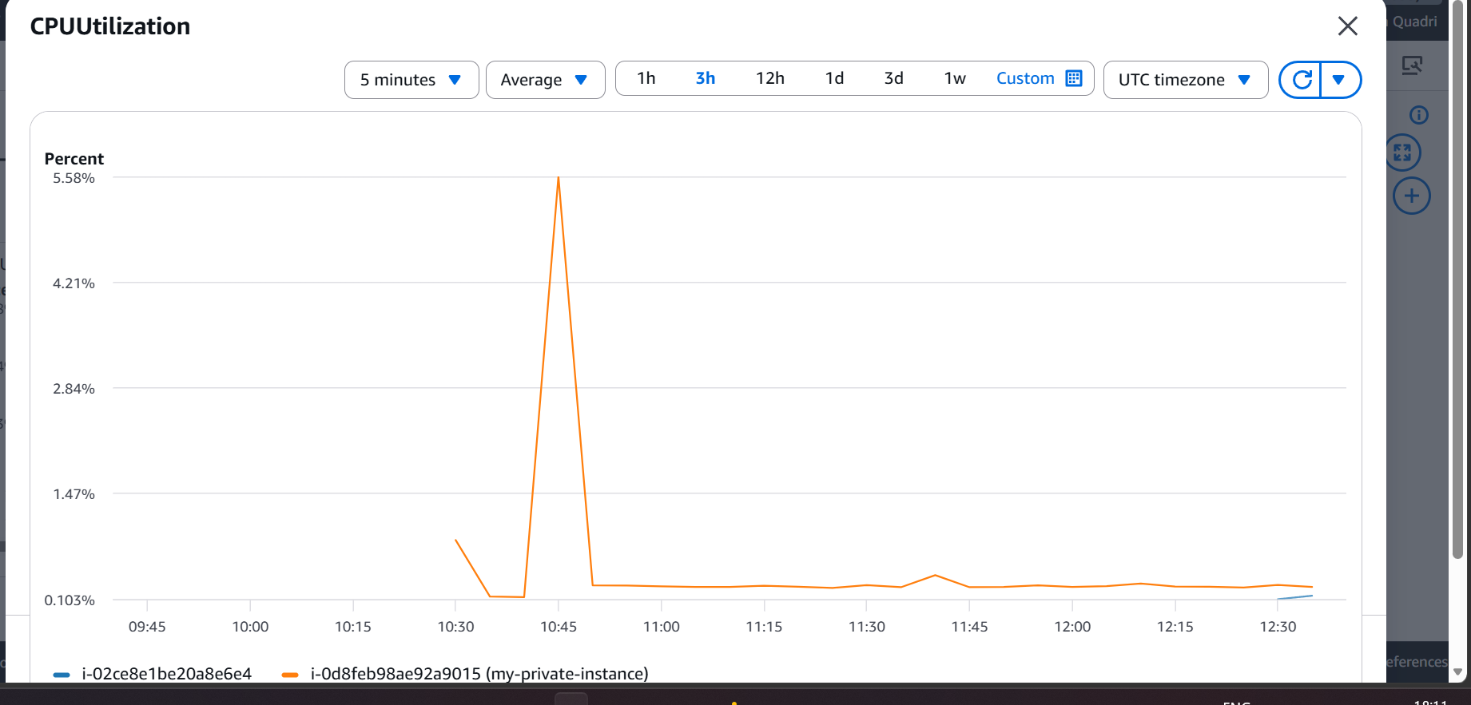
Created a dashboard
Now let us create one for apache service status
For this we need to login to our instance
And create a bash script
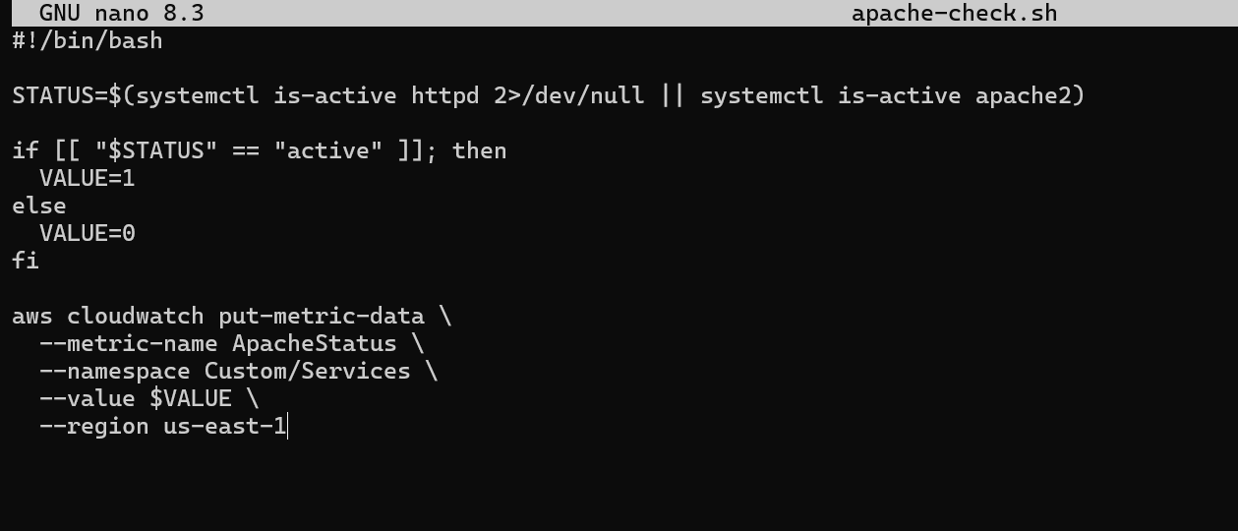

First let us enable aws cli access
Create access key
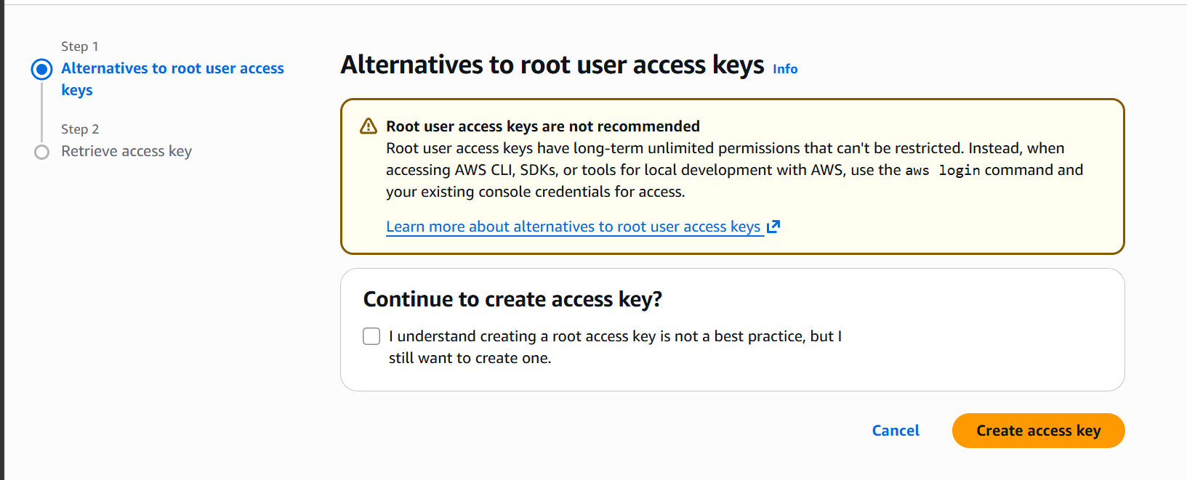
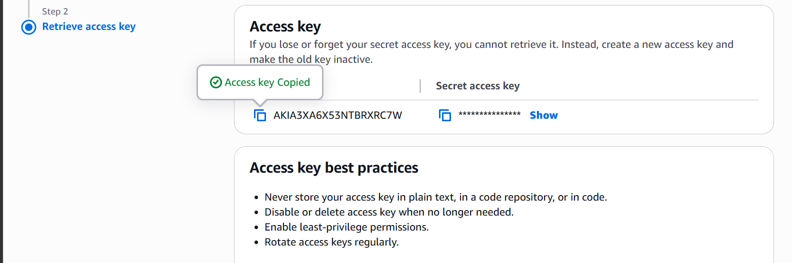

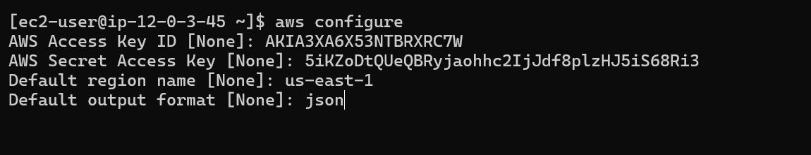
Let us now execute our script

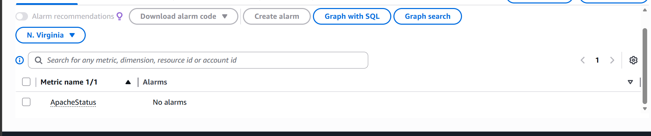
We can now see that a custom metric is created.
Let us now add it to dashboard
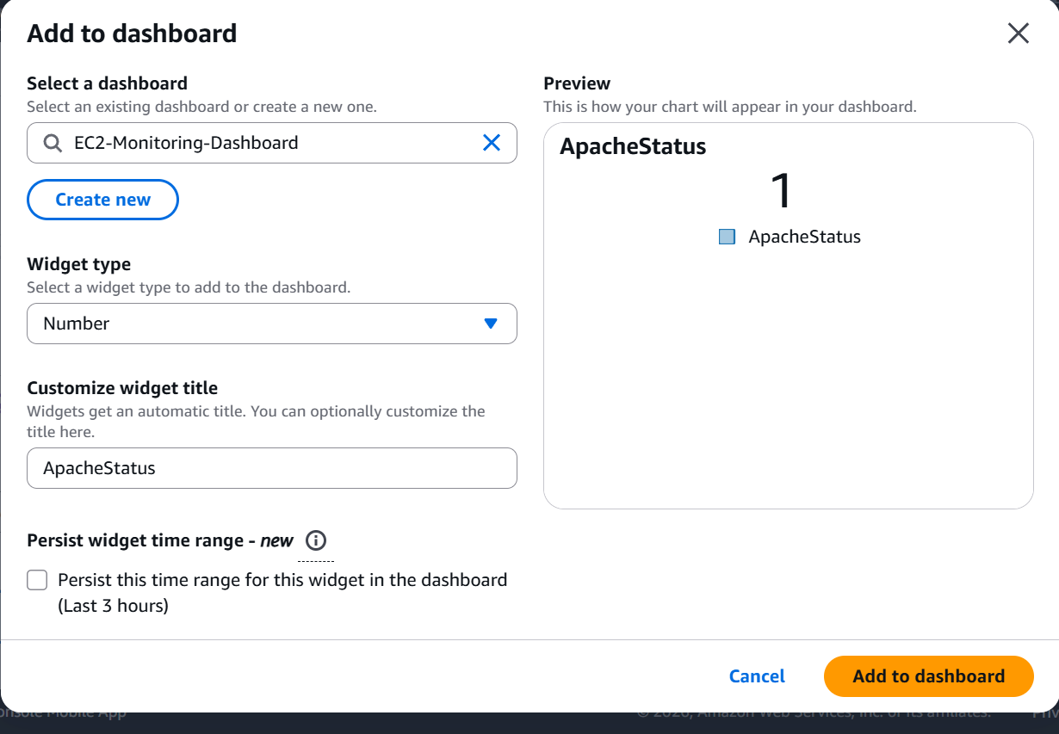

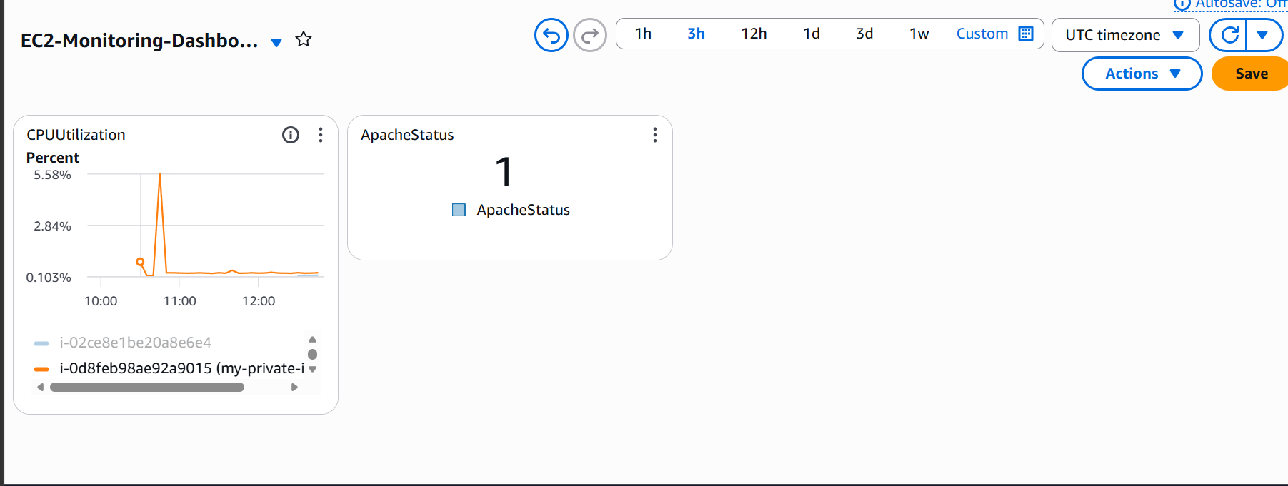

The apache status is also added to our dashboards

Task12.If CPU utilization is more than 70%, then it should trigger auto scaling and launch new instance.
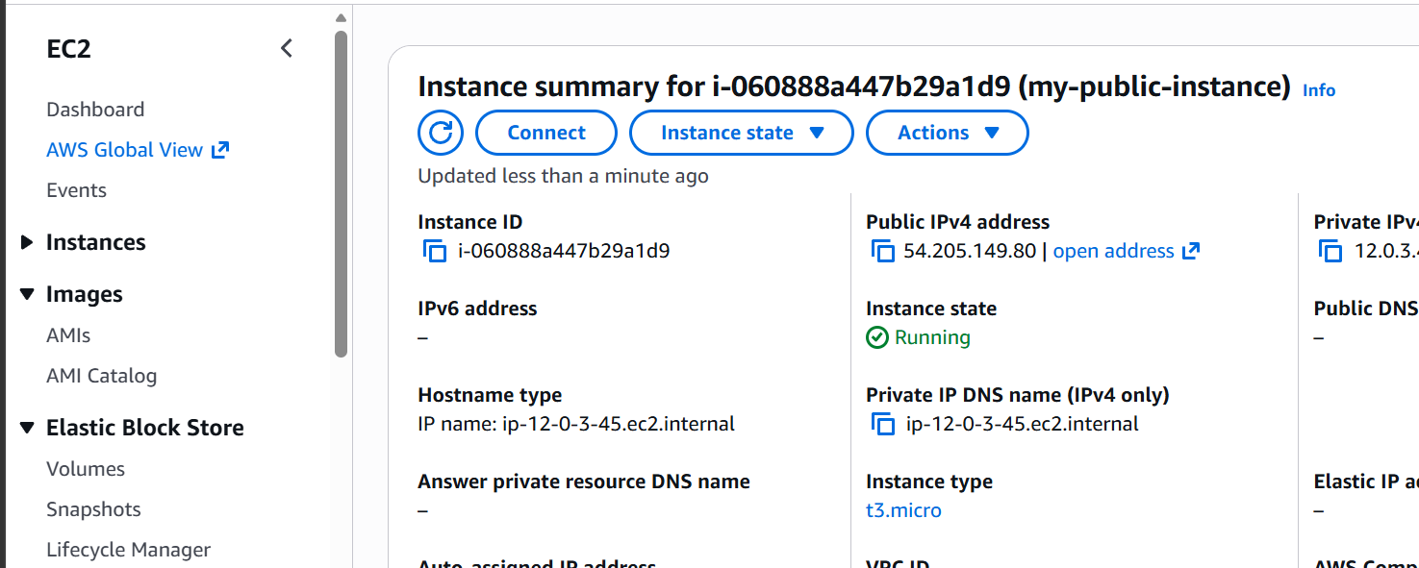

Selected my instance
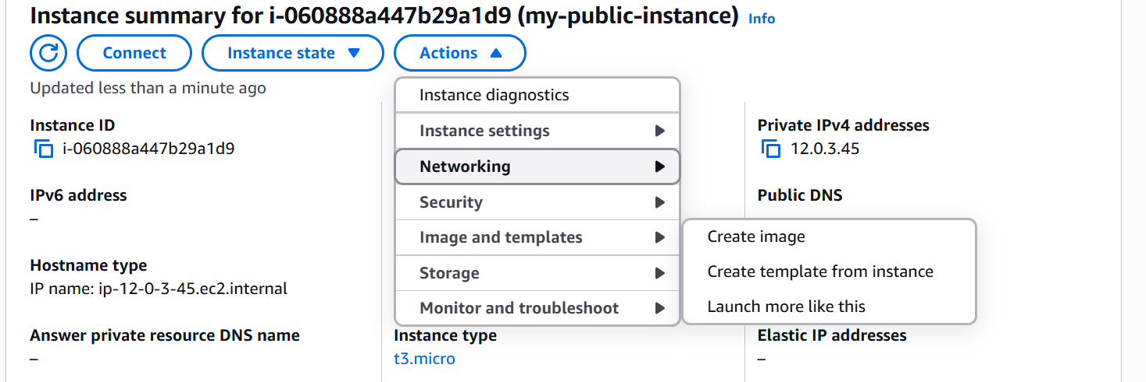
Click on actions, images and templates and create image
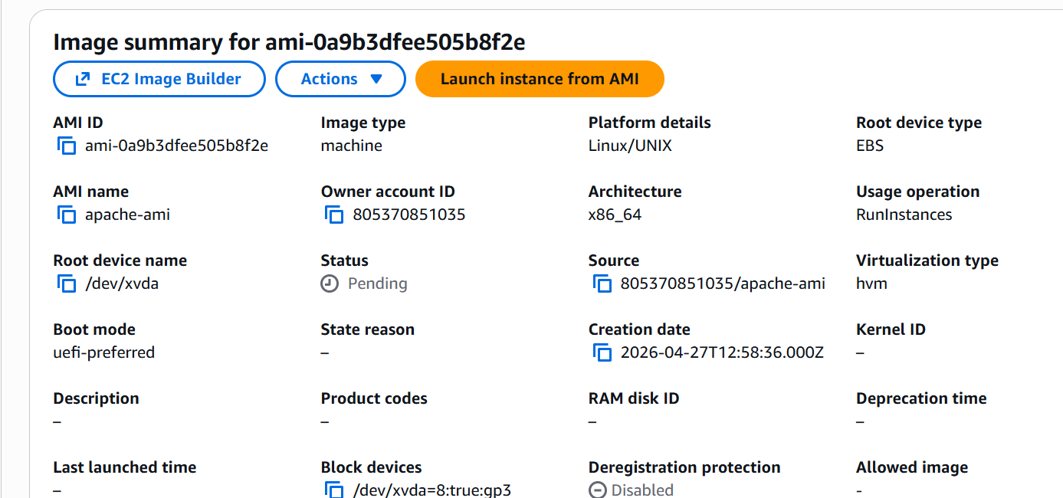
Image is now created
Create a launch template now
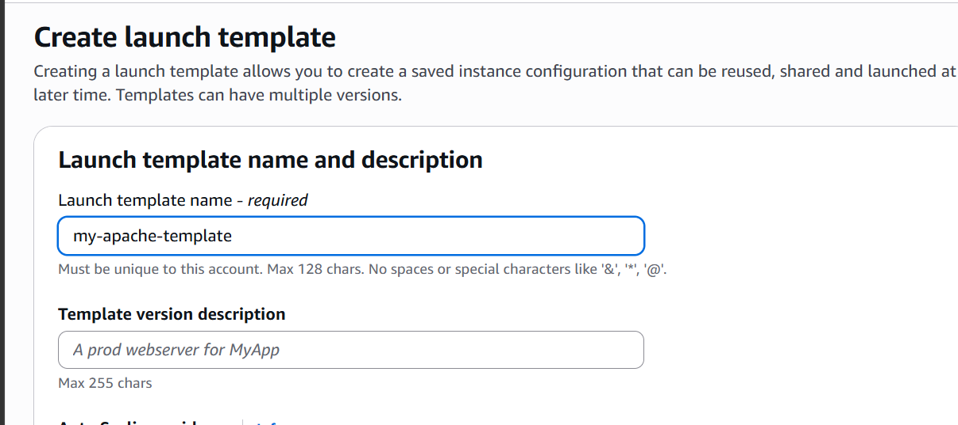
Give it a name
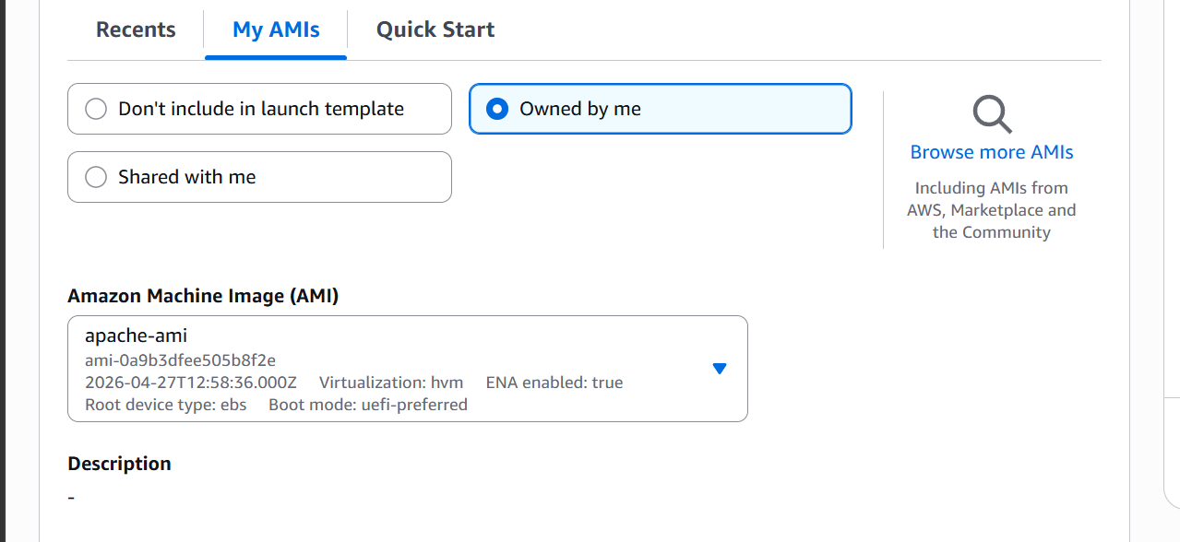
Select ami
Now select instance type and keypair
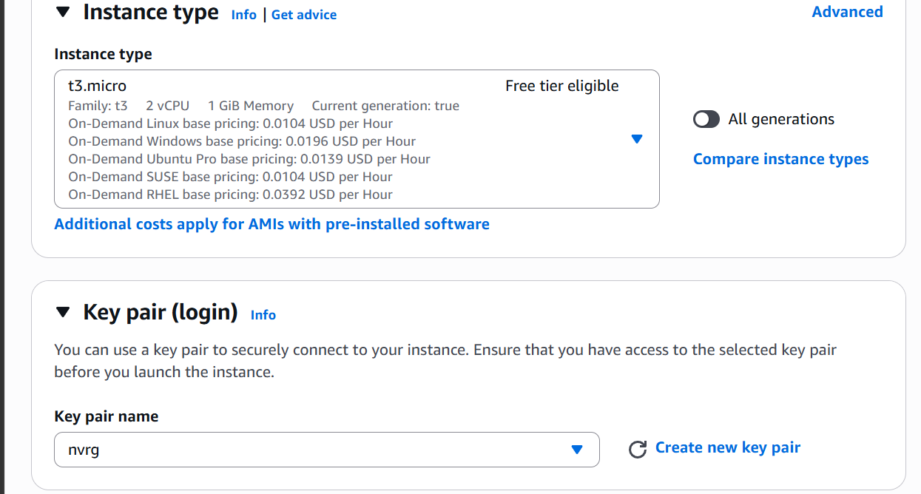

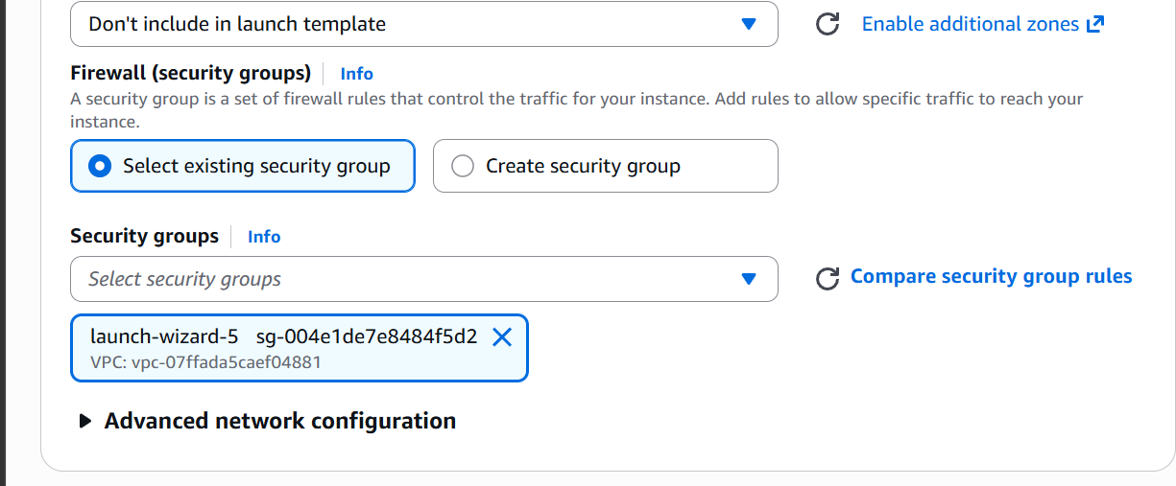

Security group selection
Now click on create launch template
Now let us create a autoscaling group from the template
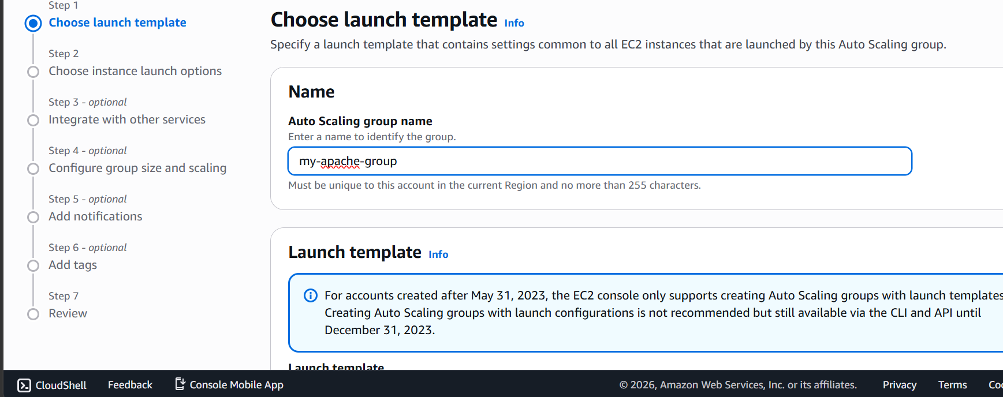

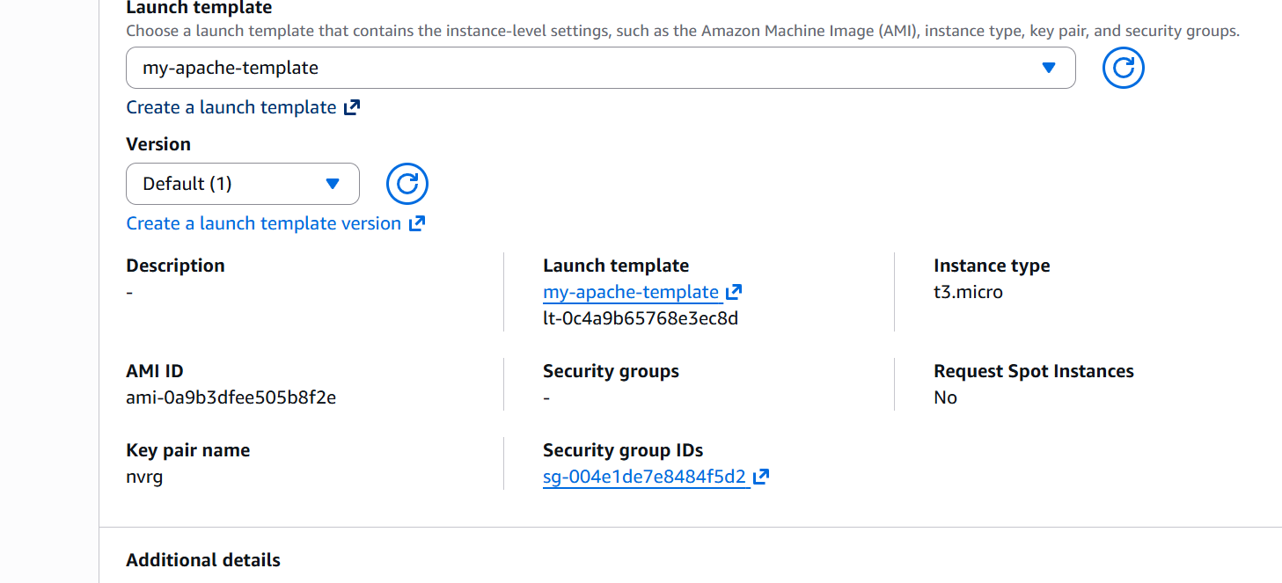

Selecting a template

Now select VPC and subnets
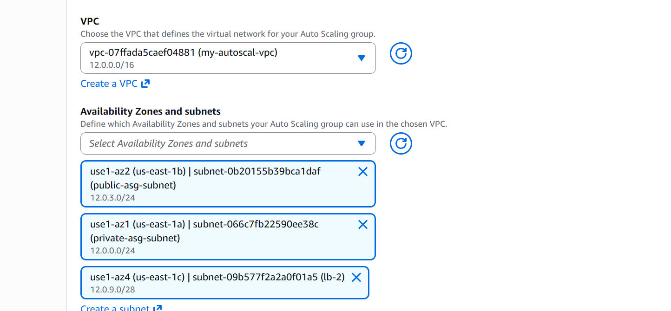

Attaching it to our load balancer target group
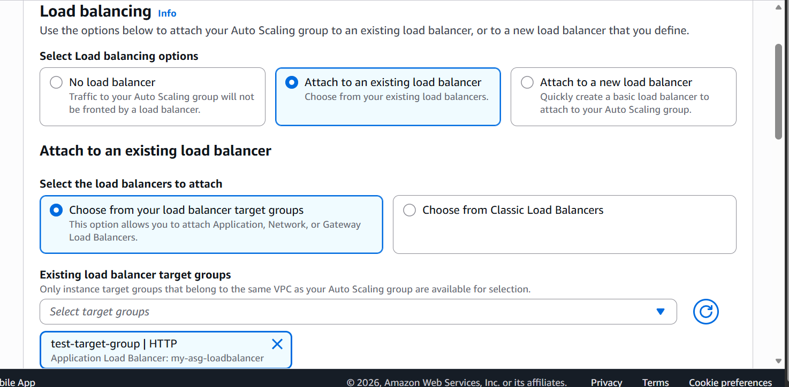
Selecting capacity
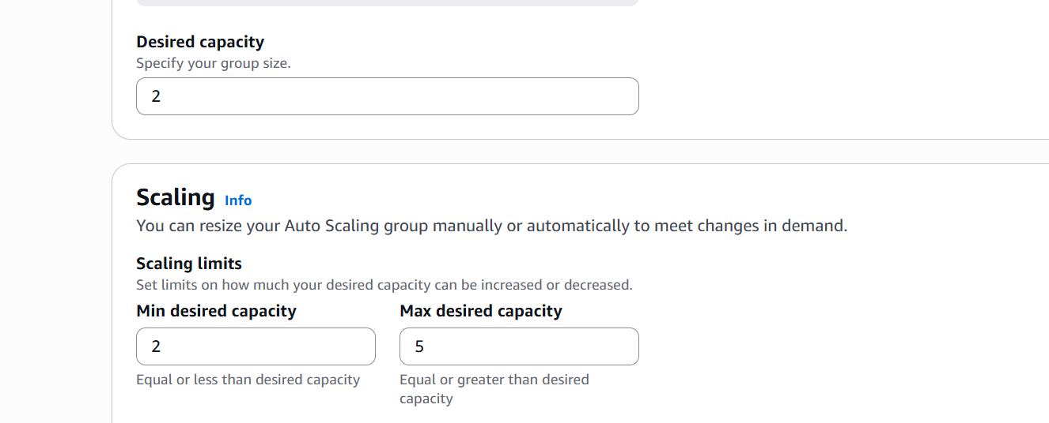

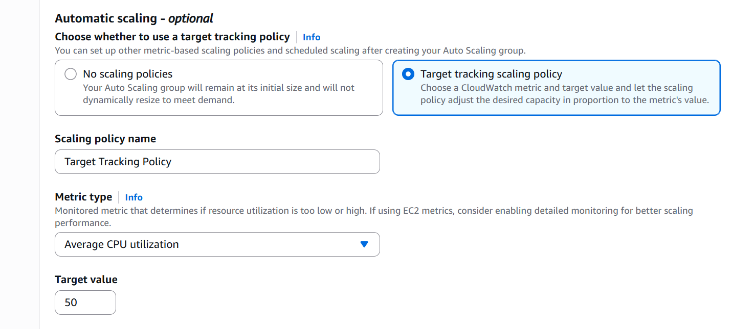

Select target tracking scaling policy

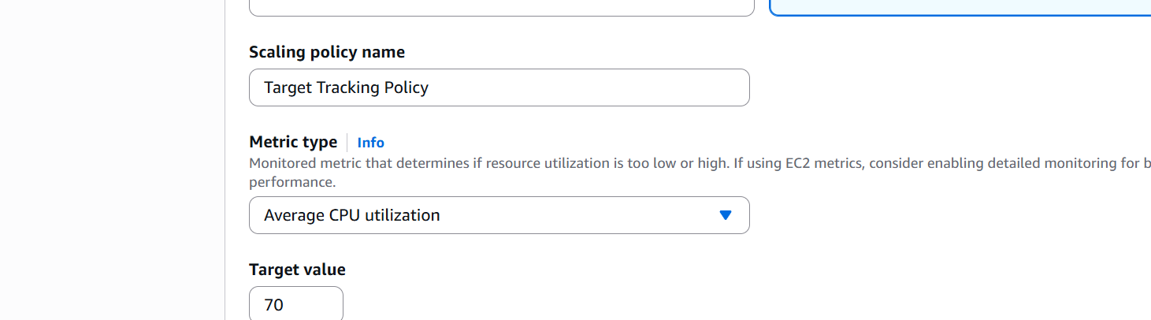

Changing target value to 70

Now let us create autoscaling group
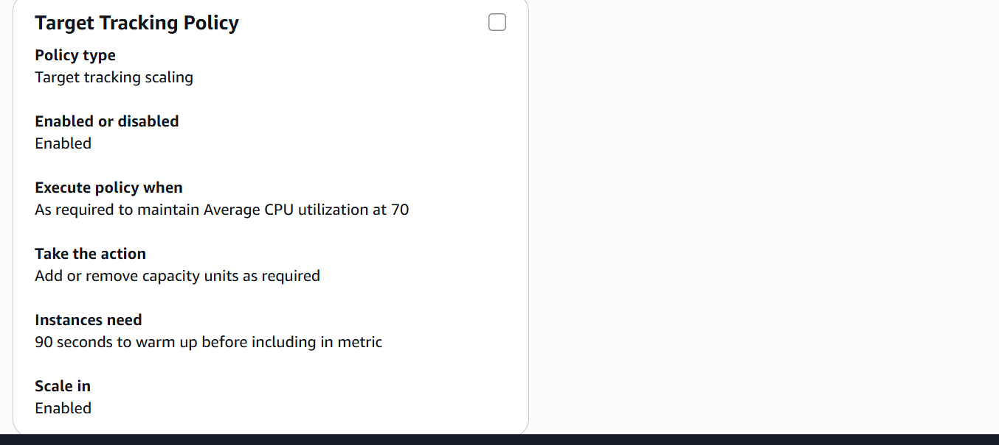

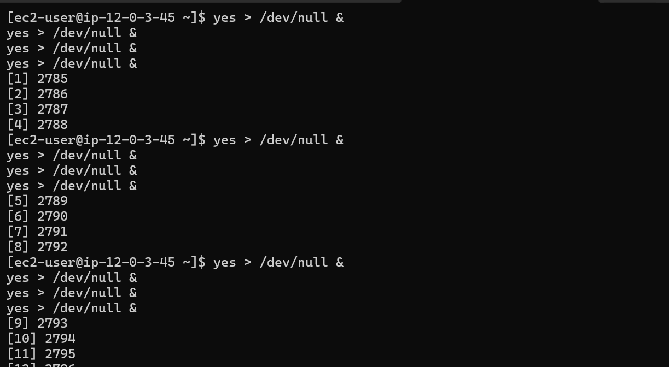

Increased load on our CPU
Now the automatic scaling will happen
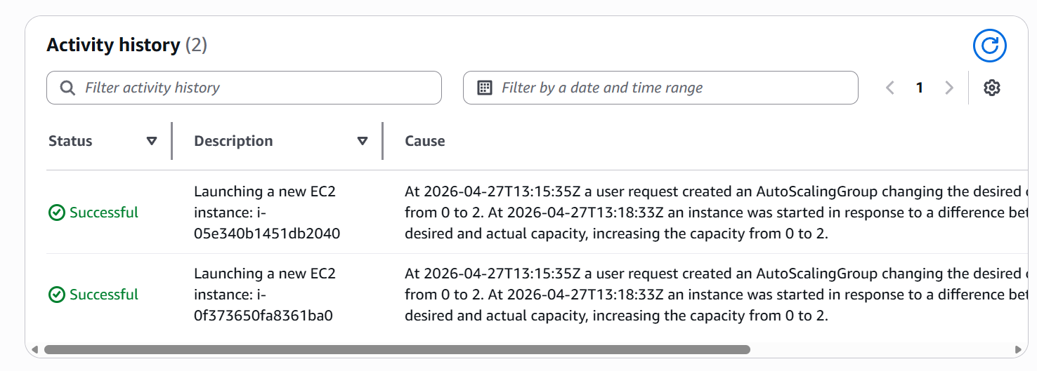

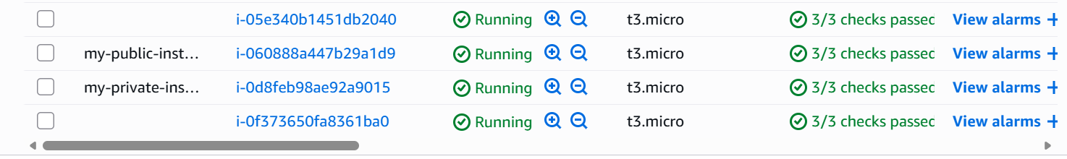

We can see that the instances are created automatically when CPU percentage crossed 70 percent threshold.

